|  |
| --- |
| **Projet ANR-N-GREEN**  **Convention ANR-15-CE25-0009-0x** |

**Deliverable D1.2**

**N-GREEN network architecture description**

Partners of the project

Alcatel-Lucent Bell Labs / NOKIA (ALBLF)

Institut Mines Telecom (Telecom ParisTech, Telecom Bretagne, Telecom SudParis) (IMT)

University of Versailles (DAVID)

III-V Lab (III-V Lab)

|  |  |
| --- | --- |
| Challenge | « Information and Communications Technology (ICT) – 2015 » |
| Project (acronyme) | **N-GREEN** |
| Coordinator of the project | NOKIA/Alcatel-Lucent Bell Labs France |

|  |  |
| --- | --- |
| Partners involved | NOKIA/Alcatel-Lucent Bell Labs France, III-V Lab, IMT, DAVID |
| Reference of the convention/decision | Convention ANR-15-CE25-0009-0x |
| Period of the project  (starting date – ending date) | January 1st, 2016 –December 31st, 2017 (extensible up to September 30th, 2018) |
| Objet | Deliverable D1.2.: N-GREEN network architecture descrption |
| Due date | December 31st, 2016 |
| Contributors of the deliverable | Philippe Gravey, Annie Gravey, Ahmed Triki (IMT-TB), Catherine Lepers, Tulin Atmaca, Djamal Zeghlache, Franck Gillet, Wiem Samoud, Amira Kamli, Djamel Amar (IMT-TSP), Cédric Ware (IMT-TPT), Dominique Barth (DAVID), Dominique Chiaroni, Brice Leclerc, Bela Berde, Philippe Carré, Joël Leclair (ALBLF). |
| Delivery date | December 31st, 2016 |

# Summary

|  |
| --- |
| This deliverable describes the potential N-GREEN network architectures. N-GREEN aims at capitalizing on mature technologies that are mostly derived from developments realized for next-generation optical access networks.  The proposed approach is based on WDM optical packets, in order to benefit from the wide bandwidth of optical gates and switches. Thanks to the progresses of optoelectronic integration, this approach is expected to take advantage of low cost technologies while offering an excellent performance.  The N-GREEN network architectures rely on key features implemented in network nodes, including a WDM by-pass of a packet node.  The considered use cases targeted in N-GREEN are aggregation/metro networks and Xhaul network architectures. |

Table of Content

Table des matières

Summary 2

I. Introduction 8

II. General context 8

II.1 General context 9

II.2 Use cases 9

II.2.1 General N-GREEN use cases identified in D1.1 9

II.2.2 Information Distribution modes 12

II.2.3 N-GREEN network scenarios 12

III. Description of the N-GREEN solution 13

III.1 Controlling a N-GREEN network 13

III.2 Specificities of the network solutions 15

III.2.1 N-GREEN for metro networks 15

III.2.2 N-GREEN for Xhaul networks 15

III.2.3 Types of N-GREEN nodes 15

III.3 Supporting Unicast and Multicast in N-GREEN Networks 15

III.3.1 Ring-based network 15

III.3.2 Mesh network 16

III.4 N-GREEN data plane protocols and mechanisms 17

III.4.1 Insertion/extraction processes 17

III.4.2 Introducing labels to support a connection oriented mode 19

III.4.3 Fast control by the control channel 22

III.4.4 Dynamic configuration of the network nodes 25

III.5 N-GREEN control plane protocols and mechanisms 27

III.5.1 Splitting the control between the node and the SDN controller 27

III.5.2 Dynamic Control by the SDN controller 28

III.6 NGREEN protocols and mechanisms for protection 28

III.6.1 Centralised Protection and Restoration 29

III.6.2 Distributed Protection and Restoration 30

III.6.3 Fast ReRoute: Distributed Protection and Centralized Restoration 31

III.6.4 Qualitative comparision between protection/restoration methods 33

IV. Approaches for Performance and techno-economic evaluation 34

IV.1 Specification of the KPIs, and selected benchmark 34

IV.1.1 KPIs 34

IV.1.2 Benchmarks 35

IV.2 Performance evaluation approaches 35

IV.2.1 Mathematical models and simulation platforms 36

IV.2.2 Simulation scenarios 36

IV.3 N-GREEN network dimensioning 38

IV.4 Techno-economic assessments 42

IV.4.1 General approach 42

IV.4.2 The comparison method 43

IV.5 Energy consumption evaluation 44

V. Physical Aspects 46

V.1 NGREEN physical limits 46

V.2 Upgradability and scalability issues 46

VI. Conclusion 49

References 51

Table of Figures

Figure 1: N-GREEN bus in a physical ring topology 9

Figure 2: N-GREEN buses in a meshed topology (Buses with the same color use the same wavelength band). Nodes A, B, F, G and H are switches and the other are bridges. 10

Figure 3: N-GREEN rings in a meshed topology (Rings with the same color use the same wavelength band). Nodes A and B are switches and the other are bridges. 10

Figure 4: Relationship between a controller, a client node and an N-GREEN node 13

Figure 5: Unicast traffic sent between two bridge nodes 15

Figure 6: Multicast traffic support in a ring network 15

Figure 7: principle of WDM packet generation 16

Figure 8: MAC Layer structure and Packet encapsulation 18

Figure 9: MPLS label format 19

Figure 10: Structure of a N-GREEN data packet 20

Figure 11: Generic format of OAM messages 22

Figure 12: Structure of the control packet in the Metro use case 22

Figure 13: Structure of the control packet in the Xhaul use case 24

Figure 14: Forwarding Information Base for an N-GREEN node (Metro uses-cases) 24

Figure 15: Forwarding Information Base for an N-GREEN node (Xhaul use case) 26

Figure 16: Centralised protection and restoration of unicast traffic 28

Figure 17: Information relative to the flows concerning D4 29

Figure 18: Distributed protection and restoration of unicast traffic 30

Figure 19: 1:1 Fast Reroute. Distributed protection and centralized restoration 31

Figure 20: 1:n Fast Reroute. Distributed protection and centralized restoration 32

Figure 21: Shortest path unidirectional transmission scenario (a) normal operation, (b) failure case 37

Figure 22: dimensioning example (concentration/distribution scenario with 28 Gbit/s per ring node), w/o traffic splitting: three 100 Gbit/s wave-bands are necessary. 38

Figure 23: dimensioning example (concentration/distribution scenario with 28 Gbit/s per ring node), with traffic splitting at node 1: only two 100 Gbit/s wave-bands are necessary 38

Figure 24: reference 17-nodes meshed network topology (distances in km). 39

Figure 25: network of Figure 24 covered by a single ring. 40

Figure 26: network of Figure 24 covered by three interconnected rings. 40

Figure 27: Evolution of the cost of a 10- nodes ring network for Ethernet and N-GREEN (WSADM) technologies. 43

Figure 28: Network synoptic and selection of technologies per network segment. 44

Figure 29: Energy gain obtained per year, with different units (euros, saved Megatons of CO2, …). 44

Figure 30: N-GREEN node studied in the frame of a ring network topology. We assume that the singals are terminated at the edge node 46

List of Tables

Table 1: Qualitative comparison of protection/restoration methods in an N-GREEN ring network 32

Table 2: MEF target CoS values for unicast traffic in metro networks ([3]) 34

Table 3: Impacts of the different physical effects on the network on the node, on the data channels and on the control channel. 47

List of Acronyms

|  |  |
| --- | --- |
| BBU | Base Band Unit |
| CAPEX | Capital Expenditures |
| CDR | Clock and Data Recovery |
| CN | Concentration Node |
| CO | Central Office (at the interface between access and metro/access networks) |
| Core CO | Core Central Office (at the interface between metro/core and core networks) |
| COS | Class of Service |
| CPE | Customer Premises Equipment |
| CPRI | Common Public Radio Interface |
| C-RAN | Centralised, Co-operative, Cloud or Clean RAN |
| CTS | Client To SDU |
| DN | Deterministic Networking |
| DSL | Digital Subscriber Line |
| DSLAM | Digital Subscriber Line Access Multiplexer |
| EN | Edge Node |
| FEC | Forwarding Equivalence Class |
| FRR | Fast ReRoute |
| FTTH | Fibre To The Home |
| HARQ | Hybrid Automatic Repeat reQuest |
| IP | Internet Protocol |
| ISP | Internet Service Provider |
| KPI | Key Performance Indicator |
| LINC | Link Is Not Closed (software switch, OpenFlow compliant) |
| LINC-OE | LINC-Switch for optical emulation |
| MAC | Media Access Control |
| Main CO | Main Central Office (at the interface between metro/access and metro/core networks) |
| MBS | Macro Base Station |
| MEF | Metropolitan Ethernet Forum |
| MPLS | Multiprotocol Label Switching |
| NBI | Northbound Interface |
| NG-PON2 | Next Generation Passive Optical Network |
| NFV | Network Function Virtualisation |
| NFVI | Network Function Virtualization Infrastructure |
| NFVO | NFV Orchestrator |
| OAM | Operation, Administration and Maintenance |
| OF-CONFIG | OpenFlow Management and Configuration Protocol |
| OLT | Optical Line Termination |
| ONF | Open Networking Foundation |
| OPEX | Operational Expenditures |
| PDU | Packet Data Unit |
| PE | Provider Edge |
| PIT | Protection Information Table |
| POADM | Packet Optical Add Drop Multiplexing |
| POP | Point of Presence |
| QoE | Quality of Experience |
| QoS | Quality of Service |
| RAN | Radio Access Network |
| ROADM | Reconfigurable Optical Add-and-Drop Multiplexer |
| RRH | Remote Radio Head |
| RRU | Remote Radio Unit |
| R-SOA | Reflective Semiconductor Optical Amplifier |
| SBI | Southbound Interface |
| SDH | Synchronous Digital Hierarchy |
| SDN | Software Defined Networking |
| SDU | Service Data Unit |
| SIT | Switching Information Table |
| SOA | Semiconductor Optical Amplifier |
| SONET | Synchronous Optical NETwork |
| STP | SDU To PDU |
| TTL | Time To Live |
| TWIN | Time-Domain Wavelength Interleaved Network |
| VPN | Virtual Private Network |
| WDM | Wavelength Division Multiplexing |
| WSADM | WDM Slotted Add/Drop Multiplexer |
| WSS | Wavelength Selective Switch |

# Introduction

This document is the second N-GREEN deliverable released by WP1. Deliverable D1.1 presented an overview of the main issues and evolution trends of optical networks and provided the general guidelines of the activities carried in the framework of N-GREEN project. In particular the emphasis was put on a few key issues, such as the expoitation of parallelism along the WDM dimension, a specific focus on mature techonogies and optoelectronic integration, power consumption reduction and equipment scalability, while targeting a lower cost than the widely deployed electronic Ethernet technology. Two main proposal were formulated in that context: a WDM slotted optical packet optical add-and-drop multiplexer, that can be seen as an evolution of the concept of Packet Optical Add Drop Multiplexing (POADM[1]) by introducing a new WDM packet structure, and a modular high capacity backplane for the interconnection of line cards inside a switch/router. The introduction of the latter technology only impacts the internal structure of a node, and neither its interfaces nor the protocols that it supports. On the other hand, the deployment of WDM Slotted Add/Drop Multiplexer (WSADM) equipment relies on the deployment of a new optical networking technology, exploiting a WDM packet concept, and thus requires the specification of new network architectures.

Therefore, a preliminary work is required to define a global optical networking solution based on WSADM concept, in order to get a suitable framework for assessing it, according to different technical and economical criteria. This implies making some choices on the network architecture’s key functionalities. These choices are somewhat facilitated by capitalizing on the results obtained for POADM technology. However, the specifities of the N-GREEN technology and the large variety of use cases and network segments taregetted in this project deserve an in-depth analysis of the possible architectures and a carefull assessment of their respective potential by combining various points of view such as network performance, cost comparison with conventional technologies and impact on global network energy consumption.

The document is organized as follows. Section II recalls the overall network context, the general use cases defined in D1.1 and identifies representative network scenarios. Section III gives an overview of N-GREEN networking solutions by addressing key items, such as offered features, network control, label-based operation, data and control packet structures, protection and restauration options… Section IV is dedicated to the methodology to be used for assessing the performance of the proposed solutions including KPIs identification, performance evaluation, network dimensioning, techno-econmical benchmark and energy consumption analysis. Then section V briefly recalls the main physical parameters impacting the scalabilty of N-GREEN network. Finally, the main conclusions are listed in section VI, together with the future objectives of WP1 activities.

# General context

## General context

The main evolution trends of telecom networks have been recalled in deliverable D1.1. They include a growth of the global traffic, where video contents play a major role, an increase of the proportion of the traffic issued from mobile terminals (particularly in the context of 5G introduction) and the deployment of small size data centres at the edge of regional networks. Another major change, which concerns the control plane, is the emergence of networks operated “as a service” due to the introduction of SDN and NFV paradigms. Finally, energy efficiency has become a major criteria, in order to limit the CO2 emission of these future networks.

The introduction of optical switching technologies present a great potential for improving the energy efficiency of the switching nodes of these future regional (or metropolitan) networks. In spite of several impressive laboratory demonstrations of optical packet switches, optical switching is only performed at the wavelength channel level, e.g. in ROADMs in present operational networks. N-GREENs aims at capitalizing on the rather mature technologies (mostly derived from developments realized for next-generation optical access networks). The proposed approach will be based on WDM optical packets that allow taking the best benefit from the wide bandwidth of optical gates and switches, which becomes cost-effective thanks to the progresses of optoelectronic integration of the transceivers.

The introduction of a new networking technology, like the one proposed by N-GREEN, will be possible only if it is able to satisfy key challenges in terms of cost and performances. A preliminary list of targeted characteristics was shown in D1.1. for different network segments.

Regarding the cost issues, it is clear that, at least for metro networks, where Ethernet is the dominant technology, N-GREEN solution needs to be cheaper than Ethernet one. Some technical characteristics may be defined by introducing KPI (that may depend on the use cases), which can be evalued by suitable performance evaluation techniques, as described in section IV.1.1. These KPI include latency and jitter (end-to-end or for a given network segment) and also network availability.

Other expectations that have to be fullfiled include energy efficiency, scalability and future safeness. The later points are linked. It is clear that a disruptive technique like N-GREEN will only be introduced if it is expected to satisfy the network requirement during a sufficiently large time window. Probably around 10 years, that roughly corresponds (assuming ~30% yearly traffic growth) to the ability to support at least a 10 times traffic increase.

## Use cases

### General N-GREEN use cases identified in D1.1

N-GREEN targets three uses cases that were recalled in D1.1:

* Use case 1: A low cost solution, competitive with electronic transport of Ethernet, based on a physical ring topology for the metro area. The network segments targeted are: the metro access/aggregation for the wireline part, the fronthaul and the backhaul links for the wireless part.
* Use case 2: New solution for the metro core and the backbone, supporting mesh topologies, to implement high capacity dynamic bypasses, in order to offer an efficient interconnection layer for inter-data centre communications.
* Use case 3: Modular high capacity backplane for the interconnection of line cards inside a switch/router.

However, the third use case is not related to networking issues but to node issues and thus shall not be addressed in the present deliverable.

Use case 1 is illustrated in Figure 1.



Figure 1: N-GREEN bus in a physical ring topology

There are two types of nodes: those on the ring (described as “bridge nodes” in the next section) and the node that “closes” the ring by an electrical bridge (described as an optical switch node in the next section). In normal conditions, there is no transit traffic crossing this hub node. The electrical bridge only serves in case of single cable failure in order to preserve global connectivity. This use case is particularly suited to a concentration/distribution traffic matrix where most of the traffic in the ring is sent/received by a single node. There are two types of nodes: those inside the bus (described as “bridge nodes” in the next section) and the node that “terminates” a bus and possibly interconnects different buses (described as an optical switch node in the next section).

Use case 2 is illustrated with different figures, addressing all the same physical topology. In the approach shown in Figure 2, buses are not “closed” (i.e. they are not ring). Buses are interconnected by switch nodes.



Figure 2: N-GREEN buses in a meshed topology (Buses with the same color use the same wavelength band). Nodes A, B, F, G and H are switches and the other are bridges.

In this case, protection would entirely rely on mechanisms typical of meshed networks.

Another option would be partly or fully cover the meshed network by rings similar to the one in use case 1 and to partly or fully rely on ring-based mechanisms for protection. One example is shown illustrated in Figure 3.

The previous examples are an illustration of the possible use of N-GREEN WSADM technology in meshed networks. An in-depth study of topology design, taking into account, e.g., relative cost of switch and bridge nodes, transparent node cascadability, protection architecture,… would be required in order to identify the most pertinent design options for given physical topologies and traffic matrices. This is clearly outside the scope of this deliverable.



Figure 3: N-GREEN rings in a meshed topology (Rings with the same color use the same wavelength band). Nodes A and B are switches and the other are bridges.

### Information Distribution modes

Two modes have been proposed:

* Unicast/Multicast mode
* Broadcast-and-Select mode

In the Unicast/Multicast mode, slots are used by data packets sent to a single other node (unicast) or to a group of other nodes (multicast). This mode is similar to IP or MPLS networks. In the remainder of this document, this mode shall be named “N-GREEN for Metro Networks”.

In the Broadcast-and-Select mode, slots are received by all nodes. A node may then insert traffic for multiple destinations in a single slot; each node copies all the slots and filters their content in order to receive relevant information. This mode is similar to the downstream transfer mode in a PON. In the remainder of this document, this mode shall be named “N-GREEN for Xhaul Networks”.

### N-GREEN network scenarios

The N-GREEN use cases identified in the previous section only address the virtual topology of the network to consider. In the present section, we identify several network scenarios in which N-GREEN networks could be applied.

#### Aggregation network for an ISP

The aggregation network can be a single ring, linking Ethernet nodes (switches, OLTs, DSLAMs) attached to N-GREEN bridge nodes, to the IP edge of the ISP network (PoP, for Point of Presence) which is attached to an N-GREEN switch node.

Depending on the topology of the area, it could also be a set of interconnected rings, but also with a single PoP.

Any service relying on IP (including distributed gaming and cloud based services) are distributed over the PoP.

On a ring network, the traffic matrix corresponds to traffic aggregation/distribution : the only entries of the traffic matrix that are non zero can only correspond to the interconnection between a bridge and the switch.

#### Metropolitan/Regional IP network

As previously, the network can be a single ring, or an interconnection of rings or even a mesh network. Client nodes are IP routers (e.g. PE routers, CPEs, data center edges, etc.).

Data centres and hosting locations can be client nodes in this particular case.

The traffic matrix is thus any-to-any, with a potentially large range of rates between the entries; some correspond to flows between data centres, others to private interconnections between sites of a given entreprise.

#### Supporting Xhauling

Whereas the previous two scenarios corresponded to N-GREEN for metro networks, the present one corresponds to an N-GREEN network for Xhaul networks. An Xhaul transport network interconnects Remote Radio Heads (RRH), macro or femto cells, BaseBand Units (BBU) and the IP edges of one or many ISPs [1].

The current mobile network architecture consists in distributed radio access networks. The evolutions proposed in next generations aim to build centralized/cloud radio network architectures (C-RAN) to reduce consumption costs and power at the base stations. These C-RAN architectures include simplified base stations at each antenna (RRH) and central processing units (BBU) located in the cloud. Thus, this type of architecture confronts the problem of controlling the latency in the transfer process. Low latency is considered critical for the 5G, in particular for the deployment of the C-RAN approach (allowing time constraints like HARQ to be fulfilled over non dedicated networks), or to reach E2E expected latency from 1 to 10ms (depending on targeted services). One specificity in the C-RAN context is not only the latency constraint, but also the periodicity of the data transfer between RRH and BBU. New scheduling and routing paradigms and new technologies have to be considered to guarantee delay constrained periodic data transfers. Dynamical optical bypass and dynamical management of the emission should be considered to guarantee latency constraints.

In this context, the requirement is to make progress optical networks towards high capacities and low latencies at reasonable cost. In particular, considering the CPRI standards, in case of multi-antenna deployment, the set of antenna links may advantageously be multiplexed onto different optical wavelengths, considering Wavelength Division Multiplexing (WDM), Coarse WDM and/or Dense WDM. The introduction of DWDM in fixed optical access networks (standard NG-PON2) is consistent with this approach in the DWDM optical fronthaul and participates in the fixed-mobile convergence.

As in the previous case, the traffic matrix is any-to-any, with a potential large range of rates between the entries; some correspond to large flows between RRHs and BBUs (fronthaul or xhaul) and smaller backhaul flows.

For this specific network scenario, we shall consider a 20 km N-GREEN ring network, supporting stringent QoS requirements for fronthaul traffic in terms of jitter and latency. We shall assess what type of operation is requested and whether a centralized synchronization scheme is requested to provide a fully deterministic end-to-end delay.

# Description of the N-GREEN solution

## Controlling a N-GREEN network

There is a fast (i.e. real time) control realized in line, and a slower, although dynamical, control realized thanks to the SDN controller.

The fast control is implemented trough a control channel carried over a separate wavelength, and synchronized with the data channel: during a slot, there is both a control packet and a data packet (which may be empty). This control channel has a fixed bit rate, and is not constrained by the bit rate evolution of the data plane.

The SDN controller is expected to control both the client nodes and the N-GREEN nodes; there is not necessarily a single centralized controller, but we assume that a multi-layer orchestrator coordinates the packet layer and the optical layer. This is illustrated in Figure 4.

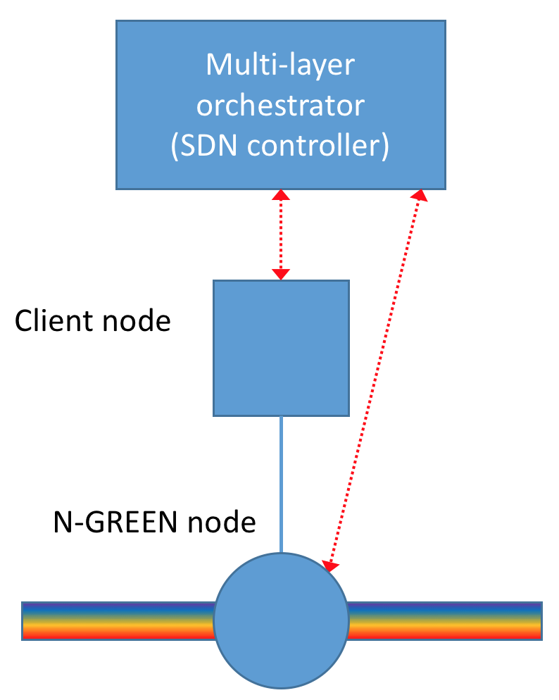

Figure 4: Relationship between a controller, a client node and an N-GREEN node

It is proposed to use an extension of OpenFlow to carry, to each N-GREEN node, the switching information computed by the controller. Depending on the type of client node accessing an N-GREEN node, different client header fields shall be used to identify client flows. It is proposed to augment OpenFlow with optical extensions in order to inject rules into N-GREEN nodes via their control channel by acting on control headers and fields to convey the rules that will be enforced by the N-GREEN nodes on data traffic and flows.

The associated natural control interface between the SDN controllers is OFCONFIG used to configure the N-GREEN nodes modes and parameters.

Following well known OpenFlow extensions and frameworks that have been designed for optical switches and transport configuration and management, another foreseen framework for the SDN to N-GREEN nodes interfaces is LINC-OE that requires the deployment of agents in the N-GREEN nodes and switches. LINC-OE provides both a switch configuration interface anchored in OFCONFIG and rules injection into switches via OpenFlow extensions. The role of the agent is to interact directly with the N-GREEN node driver responsible for implementing the desired configuration, control and management actions on the N-GREEN node electronic and optical devices and boards.

In essence, the SDN controller can interact with the N-GREEN nodes by going through the LINC-OE dedicated agent in the switch that can invoke and interact with the optical switch drivers. The orchestration and all the intelligence for calibration, configuration of N-GREEN nodes and for network wide adaptation, management and routingrouting are located at the SDN northbound intreface. They trigger all control, adaptaion and manageent actions at the nework wide level or the N-GREEN node configuration, control and management. The SDN controller southbound is used to ensure controller to N-GREEN nodes communications to apply or execute the decisions taken by the northbound applications, including flow control through rule injection and monitoring inetractions.

The direct interface between the SDN controller and the N-GREEN nodes is used to control and configure the N-GREEN nodes while the SDN controller to the client node is used in tandem with the SDN to N-GREEN nodes to control and manage the connectivity and the dynamic topologies at the wider network level beween the client nodes and the N-GREEN nodes as well as control how the flows traverse the nodes and stitched network wide.

## Specificities of the network solutions

### N-GREEN for metro networks

The first two use cases present the following features:

* connection oriented
* unicast and multicast support
* multiservice support (different traffic classes with different QoS requirements)
* data plane support (10 wavelengths sub-bands, fixed duration slots, payload spread over the 10 wavelengths),
* control plane support (1 control channel carried over a separate wavelength)

These characteristics can be offered either on ring or on bus physical topologies. However, in all cases the network is structured into transparent buses (“transparent” means here that traffic transiting from one bus extremity to the other does not experience opto-electronic conversion).

### N-GREEN for Xhaul networks

This is currently not identified in the N-GREEN use cases from D1.1

This use case corresponds also to a ring network which is operated in a broadcast-and-select manner.

* connection oriented
* broadcast support
* single service
* data plane support (10 wavelengths sub-bands, fixed duration slots, payload spread over the 10 wavelengths),
* control plane support (1 control channel carried over a separate wavelength)

### Types of N-GREEN nodes

There are two types of N-GREEN nodes:

* optical bridge nodes, with 2 bi-directional interfaces that are synchronized at the time-slot level, and with add-drop capabilities (typical nodes on a ring, or on a bus)
* optical switch nodes with 2 or more bi-directional interfaces, and electrical transit between the multiple interfaces; a hub that “closes” a ring is an optical switch node with 2 bi-directional interfaces, a node interconnecting 2 rings is an optical switch node with 4 bi-directional interfaces, a node in a mesh network may present even more bi-directional interfaces

## Supporting Unicast and Multicast in N-GREEN Networks

### Ring-based network

As data should be transported in the optical layer, it should not transit through the switch node, except in case of failure.

Therefore, for unicast traffic, in a ring network, the direction chosen to link one bridge node to another is the one that does not pass through the switch node as shown in Figure 5.

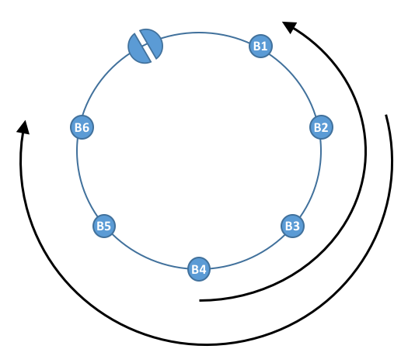

Figure 5: Unicast traffic sent between two bridge nodes

For unicast traffic exchanged between a bridge node and the switch node, both directions can be used. The direction can be chosen to be either the shortest path (in terms of geographical distance), or the path with the minimum number of hops, or to be determined when dimensioning the network in order e.g. to balance loads.

For multicast traffic, the situation is different. We assume here that multicast traffic in a ring network is handled as broadcast traffic (i.e. every node on the ring should be be able to receive every multicast flow, whatever is its source).

It is necessary to make sure that multicast optical packets are extracted as soon as every node other than the source has received them. This yields two different cases, both shown in Figure 6.

* If the multicast source is the switch node, multicast traffic is sent in one direction only, and the switch node extracts the packet after a full turn;
* If the multicast source is a bridge node, multicast traffic is sent in both directions, and the switch node extracts both copies when they are received.

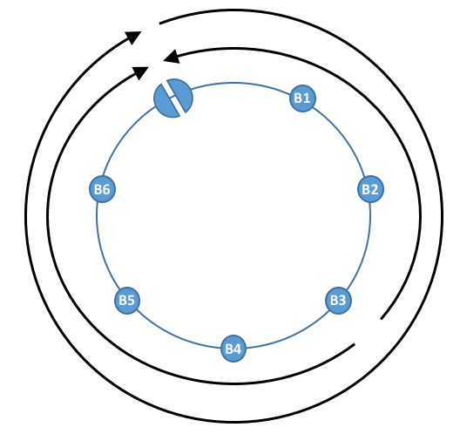

Figure 6: Multicast traffic support in a ring network

### Mesh network

The problem is not as simple for a mesh network of N-GREEN buses, as for a ring network as there is a large path diversity.

The selection of the path to be followed between nodes depends on how it is selected; various strategies can be considered, such as:

* Minimizing the number of electrical conversions undergone by the packet
* Minimizing the total number of hops, or the geographical distance

This shall be further studied in the remainder of the project.

## N-GREEN data plane protocols and mechanisms

### Insertion/extraction processes

#### Transporting a data packet over multiple wavelengths

When the node is allowed to insert an optical packet, the electronic PDU to be transmitted is split into 10 pieces which are sent simultaneously on the 10 data channels of the wavelength band (see Figure 7) and the control packet is correspondingly updated.



Figure 7: principle of WDM packet generation

The selection of 1µs for the duration of a WDM slot results from a trade-off between the maximum time a client frame waits before being sent for insertion in an optical slot, and the mean filling ratio of the electronic packet.

In the previous project ECOFRAME, we considered optical slots of 10µs duration on 10Gbit/s data channels. This corresponded to at most 12500 bytes (not taking into account guardband, preamble and framing overhead). The selection of a timer value in the order of magnitude 100 µs yielded a filling ratio close to 80% or 90%, together with a client frame sojourn time not exceeding 1ms [7][8][9]. As a larger size would have yielded either under-filled slots or a larger sojourn time for client frames, it was decided to consider the same data packet size.

However, as the electronic PDU is split over 10 data channels, the slot time for N-GREEN is also divided by 10, and is thus equal to 1µs.

#### Size of the optical N-GREEN packet

As the length of a time slot is s, and the rate carried by a single wavelength is 10Gbits/s, the maximum size of the N-GREEN data packet is 105 bits (12500 bytes).

To control the slot at the physical layer we need a preambule, in order to facilitate the clock detection in the RX part, and other fields to control the power or identify the beginning of the slot. Therefore the preamble and the guardband could reach 50-60 ns. This represents 6% of the slot duration on one wavelength.

Therefore, we assume that the data packet can use is 94% of the maximum size, i.e. 11750 bytes.

#### Insertion process for metro and Xhaul networks use cases

The process deciding that the node is allowed, or not, to insert an optical packet may differ depending on how the network is operated:

* Opportunistic insertion: whenever a slot is empty, a node can use it to transmit an optical packet; the node may decide not to use it if it considers that none of the PDUs currently being build is ready for transmission;
* Reservation mode: a slot may be empty but reserved for another node, or another class of service.

When the node is allowed to insert a PDU and there are several electronic packets ready for insertion, the node has to select which one to insert; this is “scheduling”.

Scheduling is internal to each node.

For the metro use cases, scheduling consists in selecting the packet to be transmitted when multiple packets are ready to be transmitted.

The scheduling decision can be destination based and/or CoS based; CoS covers both data plane performance, protection level and type of traffic (unicast vs multicast).

For the Xhaul use case, all outstanding SDUs are transmitted in a PDU to be broadcasted whenever the node is allowed to send a packet.

#### Reception process for metro networks use cases

A node decides to receive a packet when the PDU-level label carried by the control channel indicates that this packet belongs to a flow sent to the node.

* The node may receive the packet and free the corresponding slot by erasing the packet; this is typical for the unicast support (see Figure 5 in Section III.3);
* It may also receive only the packet, without erasing it; this is typical for the multicast support (see Figure 6 in Section III.3);
* In the multicast case on a ring, a node may be responsible to erase a packet without receiving it (see Figure 6 in Section III.3).

When the node is a switch node in a mesh network (which includes interconnected rings), a “received” PDU may not be intended for the node itself, but for another destination beyond the switch node. The switch node is then in charge of receiving the electronic packet, and of re-inserting it on another bus, or ring.

Switch nodes can discriminate between a PDU to receive locally and a PDU to switch by analyzing the control information carried by the control packet (see Section III.4.3.2).

#### Reception process for Xhaul networks use case

In the broadcast-and-select framework, every PDU is copied by every node. However, a node detects, thanks to the control packet, whether some SDUs should be received and if yes, where they are located within the PDU. Only those SDUs are then explicitly received and delivered to the client layers.

Two different sub-modes can be considered, depending on whether slot reuse is enabled, or not.

If slot reuse is not enabled, each data packet is handled as a multicast packet (see Figure 6 in Section III.3) and the switch node erases all arriving data packets.

If slot reuse is enabled, it can apply only to unicast traffic. It is necessary to carry the information that a unicast SDU has been received in the control information relative to the SDU. The receiver node marks the SDU as received in the control packet, but does not modify the data packet. When all SDUs carried in the data packet are marked as “received”, any node can take advantage of the slot, by erasing the data packet and sending a packet. In any case, as previously, the switch node erases all arriving data packets.

### Introducing labels to support a connection oriented mode

N-GREEN technology is able to carry different client protocols (IP, MPLS, Ethernet, SONET/SDH, etc.) in a connection-oriented mode. Each of these protocols present different encapsulation frame formats and may request different transport modes. An adaptation sublayer encapsulates all client data in a holistic manner, while supporting the various requirements. The operation of the MAC adaptation layer is illustrated in Figure 8.



Figure 8: MAC Layer structure and Packet encapsulation

Client data units are first encapsulated, adding network specific information. Client flows are then multiplexed, using possibly segmentation or padding, in order to obtain fixed size bursts, which shall be handled by the transport sublayer. Control information is to be carried in the control channel.

Relevant control information carried in the client header such as addressing, transport type, and QoS class, is extracted and analyzed to identify the appropriate client flow, consisting in a a forwarding equivalence class (FEC). This flow shall be identified by a service data unit (SDU) level label.

Since all the nodes can potentially receive all the traffic, a node needs a means to recognize each flow, per time slot (and per wavelength band if there are multiple bands).

This is done thanks to packet-level information carried by the control packet; when necessary, a PDU level label idenfies N-GREEN data packets.

Control packets are electronically processed at each node, in order to identify which optical packets need to be received and whether a new packet can be inserted.

#### N-GREEN label format

For the sake of simplicity, it is assumed that the MPLS label structure is used in N-GREEN for both SDU level and PDU level labels. MPLS labels are 4 bytes long, as shown in Figure 9.

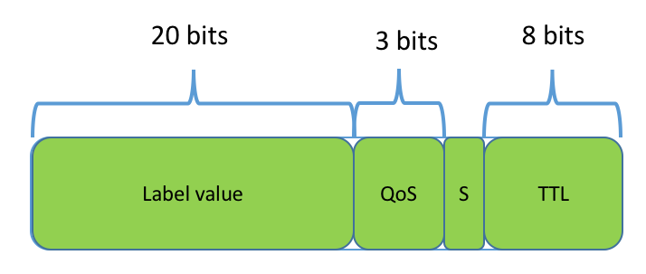

Figure 9: MPLS label format

* The label identifier is coded over 20 bits
* 3 bits are used to specify a traffic class
* the S bit is always set to 0 except for the “Bottom of Stack” label in which case it is set to 1 (when labels are stacked, the Bottom of Stack label is the first to have been associated to a packet).
* 8 bits are used in MPLS to carry a Time To Live (TTL) information; the use of this information is for further study in N-GREEN. In particular, this byte could carry information relative to whether the SDU has been received or not (see Section III.4.1.5).

#### Construction of the data packets

Fixed size PDUs are created by adding specific information regarding the physical layer, framing, synchronizing, error correction, and padding. PDUs can be considered as containers that group multiple SDUs with the same characteristics. Scheduling rules are used to select which PDU, if any, is inserted in each time slot.

Two methods shall be considered to assess whether a PDU is ready for insertion:

* “Cut-through” (by analogy with switch modes): PDUs are build from buffered SDUs and sent immediately on the available slots of ring, even if those SDUs are not sufficient to build a full size PDU. This method may reduce the latency but the resources’ use may be not optimum.
* “Store and forward”, incoming SDUs are buffered and PDUs are scheduled to be sent either when a given percentage of the total size is reached or when the first SDU has been stored for a longer time than a given time threshold. In case of multiclass services, each CoS may have a different threshold.

In case of multiclass services, we may upgrade SDUs from lower to higher priority classes, apply a different threshold for each CoS for “store and forward” mode, pre-empt packet emissions in the favor of the higher-priority classes…These CoS policies can also be applied at the transit level.

Data packets (PDUs) are build from client data units (SDUs). In order to identify the original data units, and to efficiently receive them, some information is necessary, as illustrated in Figure 10.

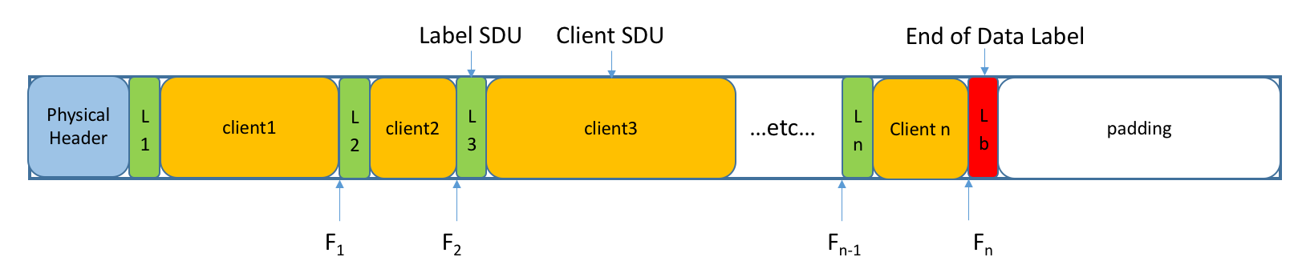

Figure 10: Structure of a N-GREEN data packet

The physical header carries a guardband and a preamble to facilitate the clock and data recovery (CDR). Both can be performed in a few 10’s of ns. A typical value between 50 and 60 ns should be sufficient to ensure the proper detection while limiting the overhead to 5-6% (see section III.4.1.2). At the end of the Physical Header, there is also a “delineation word”, i.e. a well known sequence of bits that allows frame delineation.

A label is associated to each client data unit; this is the SDU level label. A label uniquely identifies a client flow.

In order to implement the reception process, a node should be able to identify each client flow (this is made possible with the SDU level label) and also to identify when there is no more useful information within the data packet, but only padding. This is made possible by reserving a specific label value which indicates the “End-of-Data” in the data packet.

The minimum size of an Ethernet packet is 60 bytes, the minimum size of an SDU is thus 64 bytes. Considering the total size of data packet, it is easily seen that the maximum number of SDUs within a PDU is smaller than 200. In general, it is expected that the number of SDUs within a PDU is much smaller: at most 8 maximum sized Ethernet packets (1514 bytes) can be carried in an N-GREEN packet, a single jumbo frame (9000 bytes) can be carried in the N-GREEN packet.

The variables Fi are used to identify when a SDU starts and stops; as the SDUs are carried back to back in the data packet, it is necessary to carry only Fi as a new label starts just after Fi, whether it is the label of another SDU or the “End-of-Data” label.

Assuming that the SDUs are byte-aligned, two bytes more than sufficient to code Fi. Indeed, 1016 = 4x16384, and the length of the data packet is at most 12500 bytes (see section III.4.1.2); therefore 14 bits would be sufficient but byte alignment implies that 2 bytes are used.

Note that the PDU level label, when it exists (see section III.4.2.3) is not carried within the N-GREEN data packet.

#### Labels for metro network use-cases

For metro network use cases, the SDU level label is carried in a header associated with the client data.

The SDU-level label is used to implicitly identify the client layer, or, e.g. the virtual private network (VPN), or the multicast flow to which the client packet belongs; this is used for correctly and efficiently addressing demultiplexed bursts at reception.

SDU-level labels can also used to identify how client flows are to be demultiplexed; priority mechanisms can be used, e.g. to speed up the transport of client flows with stringent latency requirements.

A node identifies which PDUs to receive and extract using PDU-level labels in the control packet characterizing each PDU carried in a given time slot. PDU level labels could be stacked (as in MPLS). The decision to receive a data packet is made by observing the label at the top of the label stack.

If the data packet belongs to a unicast virtual circuit, a node receives all the SDUs within the PDU. On the other hand, if the data packet belongs to a multicast virtual circuit, the node may receive only part of the SDUs carried in the PDU. The node should thus be able to easily identify which SDUs should be received. This is explained further in Section III.4.3.2.

In switch nodes used for ring or bus interconnection, SDU flows can be groomed into new bursts without accessing the client layers. The alternative is to forward the whole data packet on another ring or bus.

#### Labels for Xhaul network use-case

For Xhaul network use case, the SDU level label is carried in the control packet, together with an offset information allowing a node to locate the SDUs within the PDU. The SDU-level label can be used to implicitly identify the client layer, or, e.g. VPN, or the multicast flow to which the client packet belongs; this is used for correctly and efficiently addressing demultiplexed bursts at reception.

A node identifies which SDUs to receive and extract using SDU-level labels in the control packet. Thanks to this information, a node can download only the SDUs it has to receive, and is not requested to filter client packets one by one. This is explained further in Section III.4.3.3.

### Fast control by the control channel

The control channel carries also the information that characterizes the data which is currently carried in the slot. It also carries information relative to Operation Administration and Maintenance (OAM); for example, when there is a failure, the nodes at the edge of the failure can send an OAM message to help the other nodes localizing the failure. The structure of the OAM messages is given in Section III.4.3.1.

There is a control packet associated to each data packet. The control packet is carried over a single (separate) wavelength. Its length is thus 1/10 of the length of a data packet, thus 104 bits (1250 bytes).

The N-GREEN node relies on the information carried in the control packet to assess whether the packet is to be received and/or erased. The structure of the control packet is not the same in the two modes. The Metro use case is described in Section III.4.3.2 and Xhaul use case in Section III.4.3.3.

#### OAM messages carried in the control channel

In order to provide a robust representation of OAM messages, it is necessary to provision for multiple types of OAM messages, and for multiple information objects carried by each message. The generic structure of an OAM message could be as shown in Figure 11.

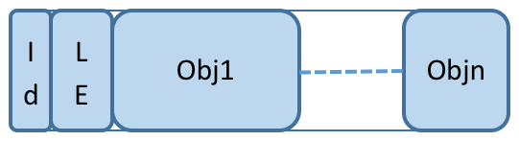

Figure 11: Generic format of OAM messages

* Id caracterises the type of OAM message
* LE is the length of the OAM message
* Each object carries information relative to OAM message (the identifier of the node sending the message, the type of failure, etc)

#### Structure of the control packet in the Metro use case

Neither guardband nor preamble (defined only for burst mode operation) are required, since the control channel is systematically demodulated at each node. We are in the case of a synchronous transmission of the control channel between two consecutive nodes, and an opto-electronic regeneration at each node. However, a “delineation word” is still necessary in order to ensure framing.

In the metro use case, the N-GREEN node receives all the SDU in those data packets corresponding to flows for which it is a receiver. This characterizes “PDU-triggered” reception. This is done by matching a PDU-level label with an entry in the switching information table defined in section III.4.4.1.

The structure of the control packet in the Metro use case is as shown in Figure 12.

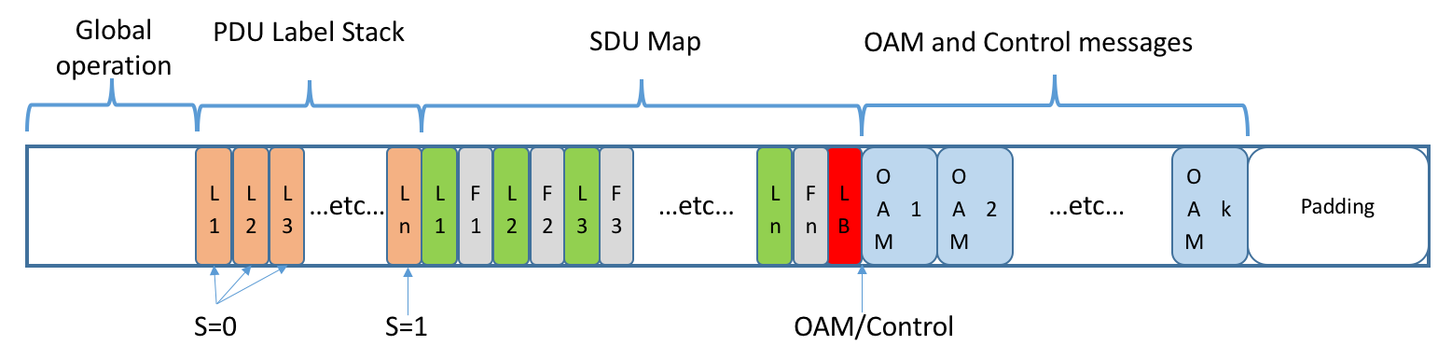

Figure 12: Structure of the control packet in the Metro use case

Global operation

Many informations are to be carried at the beginning of the control packet; the following is a list of such informations.

* Frame delineation “word”, which could be 128 bits (16 bytes)
* Available/Non-Available (1 bit)
* Reserved/Opportunistic (1 bit)
* N-GREEN node identifier of the owner of the reservation; this could be coded over 1 byte, similarly to the ONU-Id in a GPON;
* unicast/multicast (1 bit)
* protected/unprotected (1 bit) : this is used by a node adjacent to a failure to determine whether the packet should be sent in the other direction, or not, as long as the network is not restored (see Section III.6.3);
* TTL (1 byte) to make sure that non-identified packets are discarded eventually;
* Length (6 bits); the rest of the packet is padding
* CRC to protect the control packet
* Link Id: this is used e.g. in the OAM messages advertising a failure (1 byte?)

Note that it is NOT necessary to present a CoS identifier, as all optical packets on the network are offered the same transfer; however, SDU level differentiation can offered when building the PDUs.

PDU label stack

There is at least one label (see Section III.4.2.1). As in MPLS, the Bottom of Stack label is identified with S=1, whereas all other labels are identified with S=0. Stacking labels can be useful in mesh networks, for switch nodes that forward packets from one ring/bus to another. Each label is 4 bytes.

A bridge node only checks the top label, and if this label is present in its switching information table (SIT, see Section III.4.4.1), the data packet is received.

A switch node also checks the top label to assess which actions should be carried out on the packet (receive, discard, forward). If the packet is to be forwarded on another ring or bus, this is specified in the next label. This behavior is very similar to the “Segment Routing” MPLS flavor.

SDU Map

The SDU map allows locating each SDU within the data packet. Each SDU label Li identifies a flow and the exact location of the SDU within the data packet is given by Fi-1 and Fi. Each pair (Li, Fi-1) is coded over 6 bytes; as the maximum number of SDUs within a PDU is less than 200, the control packet size is not exceeded.

The SDU map in used only for multicast traffic in the Metro use case.

OAM and Network Control Messages

Room permitting, control messages coded as shown in Section III.4.3.1 can be carried in the control packet. This is a very efficient method for distributing information within a network or a network segment.

#### Structure of the control packet in the Xhaul use case

The format of the control packet is the same than in the previous case as shown in Figure 13. However, in this case, the label stack is reduced to one, and there is a reserved label value meaning “all nodes receive this packet”.

Although all nodes receive the data packet, they select the SDUs to be received by matching the SDU-level labels with an entry in the switching information table defined in Section III.4.4.2.

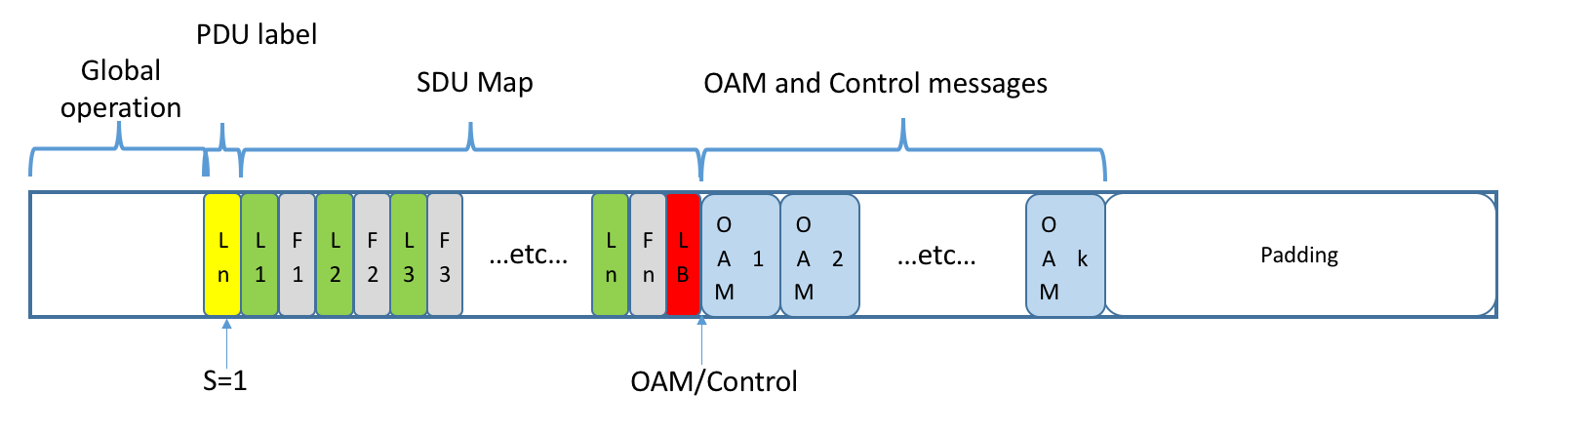

Figure 13: Structure of the control packet in the Xhaul use case

### Dynamic configuration of the network nodes

#### Metro networks use cases

A classical label-based operation is implemented in each N-GREEN node thanks to multiple local tables shown in Figure 14. These tables are described below:

* The client to SDU (CTS) table binds a client flow to a given SDU label.
* The SDU to PDU (STP) table binds SDU labels to a PDU label (and thus to a flow within the N-GREEN network).
* The switching information table presents a PDU related table (PDU-SIT) and a SDU related table (SDU-SIT)
  + The PDU-SIT maps PDU-level label to the action (i.e., operation) that the node takes on the PDU (receive, insert, erase).
  + The SDU-SIT lists the SDU level labels of the flow that the node receives; in the Metro network use case, this table is useful only for multicast PDUs, as all SDUs within a received PDU are implicitly to be received for unicast PDUs.

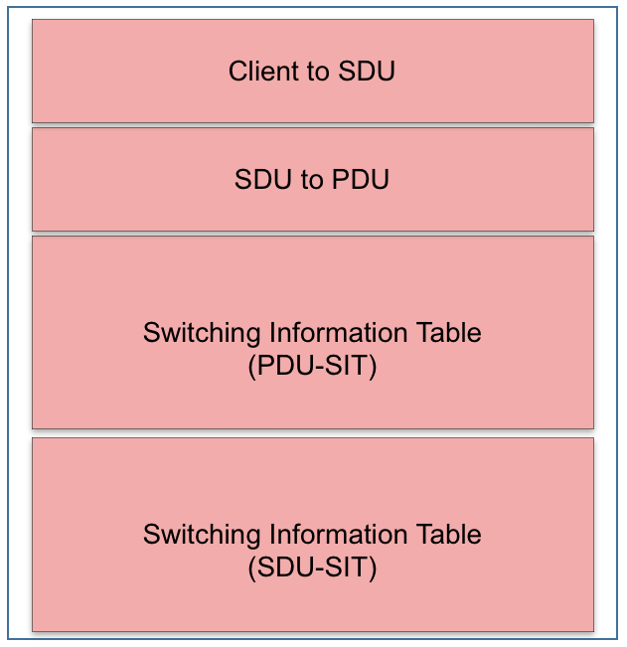

Figure 14: Forwarding Information Base for an N-GREEN node (Metro uses-cases)

At each time slot, the node processes the control packet in order to identify which action(s) to take, based on the PDU-level label characterizing each PDU. If the label is not listed in the PDU-SIT, the PDU is passed transparently. Otherwise, the SIT identifies which of the four following actions is to be taken:

* RECEIVE-ERASE: the node receives the PDU and strip it off. This is the default action for a unicast PDU.
* RECEIVE-PASS: the node receives the PDU but does not erase it from the ring. This is the default action for a multicast PDU.
* ERASE: the node erases the PDU without receiving it. This is the default action for a switch node.
* RECEIVE-INSERT: the node extracts the PDU and modifies the label stack   
  (e.g., pops the outer label), and retransmits the PDU into the network. This can be done by a switch node, or for protection purposes during a failure by any node.

When a multicast PDU is received by a node, the SDU-SIT is used to identify which SDUs to receive; thanks to the SDU map in the control packet, the relevant SDUs can be easily selectively retrieved in the data packet.

The local tables only contain information regarding the labeled flows that are handled in the electronic layer by the N-GREEN node. When a PDU label does not figure in the SIT, the flow passes transparently through the optical layer. This is very positive in terms of configuration and complexity. If a label is errored, no node would then ever erase the PDU. This can be solved by the TTL field in the control packet which is updated every time a PDU passes a node, even if it is passed transparently, as the control information for each data PDU is electronically handled in every node.

The CTS, STP, and SIT tables shall be downloaded by the SDN controller. They can be updated if there is a new entry or a change within the network (e.g. a failure, as part of a protection and restoration policy, see Section III.6).

Finally, note that PDU-SIT table may present entries with stacked labels. For example, when source and traffic destinations belong to two bridge nodes attached to different ring or buses connected by a switch node, two PDU-level labels can be inserted in the control channel during PDU generation: the first one indentifies the switch node as an intermediate destination and is popped when crossing this node and the second one identifies the destination node in the destination bus or ring.

#### Xhaul network use case

In the broadcast-and-select mode, the label-based operation implemented in each N-GREEN node is simpler as shown in the local tables shown in Figure 15.

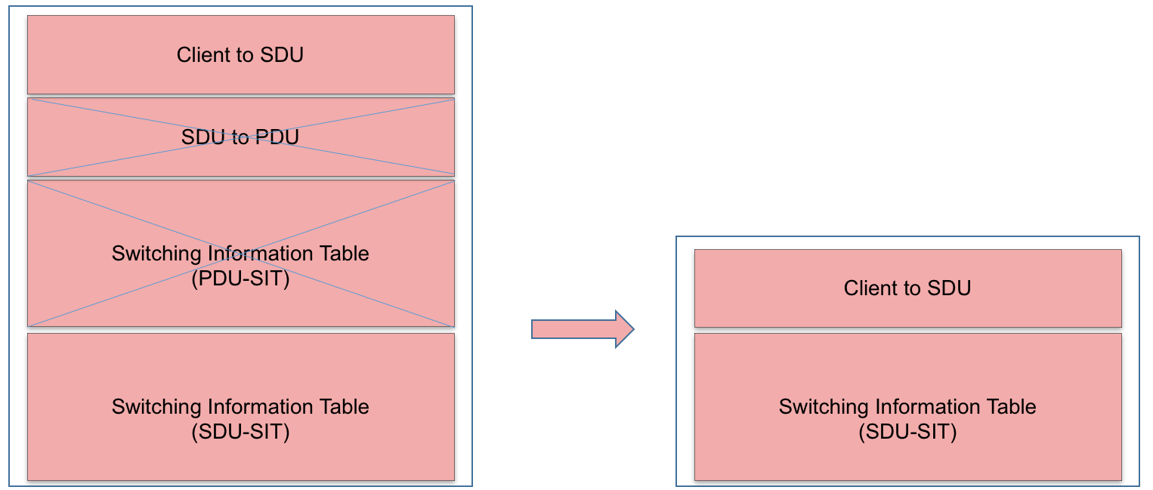

Figure 15: Forwarding Information Base for an N-GREEN node (Xhaul use case)

* The client to SDU (CTS) table binds a client flow to a given SDU label.
* The SDU to PDU (STP) table is not necessary as SDUs are all sent in a “default label” PDU, whatever is their destination.
* The switching information table presents a PDU related table (PDU-SIT) and a SDU related table (SDU-SIT)
  + The PDU-SIT is not necessary as all bridge nodes receive all data packets, which are ultimately erased by the switch node at the edge of the ring/bus.
  + The SDU-SIT lists the SDU level labels of the flow that the node receives; in the Xhaul network use case, this table is used for all data packets.

At each time slot, the node processes the control packet in order to identify which action(s) to take, based on the SDU-level information carried in the control packet. If none of the SDU labels are listed in the SDU-SIT, the PDU is passed transparently. Otherwise, the SIT identifies which SDUs to explicitly receive.

The local tables only contain information regarding the labeled flows that are handled in the electronic layer by the N-GREEN node. This is very positive in terms of configuration and complexity. If a label is errored, no node would then ever erase the PDU. This can be solved by the TTL field in the control packet which is updated every time a PDU passes a node, even if it is passed transparently, as the control information for each data PDU is electronically handled in every node.

The CTS and SDU-SIT tables shall be downloaded by the SDN controller. They can be updated if there is a new entry or a change within the network.

## N-GREEN control plane protocols and mechanisms

### Splitting the control between the node and the SDN controller

The SDN controller is in charge of matching client flows to SDU level labels for both metro and Xhaul use cases, and to match SDU level labels to PDU levels in the metro use case. It is also in charge of computing the SIT used in nodes to retrieve information from the data channel.

Information relevant to each node is downloaded by the SDN controller within the forwarding tables to be used by the node. Only the SDN controller has a global view of all the flows carried inside the network.

The control channel carries the control packets that are used by each node to identify which action to take, by matching the information within each control packet to the SIT tables currently in use in the node.

### Dynamic Control by the SDN controller

An SDN framework enables the dynamic control of the different components of the nodes to improve the reactivity of the network facing traffic profile changes, network upgrades or failures.

The basic role of the SDN controller is to specify a list of actions to perform

1. on each client packet received by a node before being inserted on the N-GREEN network,
2. on each optical packet arriving at a node,
3. on each client packet extracted from an optical packet received by a node.

This implies that the SDN controller should not only be able to characterize a flow in terms of client layer characteristics, but also in terms of either PDU or SDU labels.

For upstream traffic (electronic traffic to be inserted in the N-GREEN node), the list of actions includes the insertion of a single SDU label, and the forwarding of the client packet towards a (virtual) queue corresponding to a given PDU label, or label stack.

For traffic arriving at an N-GREEN node in an optical packet, the list of actions to perform the an optical packet include PASS, RECEIVE-ERASE, RECEIVE-PASS, ERASE and RECEIVE-INSERT, which correspond to the actions described in Section III.4.4.1.

For downstream traffic (SDUs recovered from received PDUs), the actions to perform include the extraction of the SDU label and the forwarding of the client packet to an appropriate electronic interface.

## NGREEN protocols and mechanisms for protection

This section presents several protection and restoration methods that can apply to an N-GREEN network. The respective performance and characterics of these methods shall be compared during the second part of project.

There are three main steps to provide protection:

* Failure notification and localization: a failure triggers the sending of messages to the other nodes and/or to the controller.
* Protection: a very fast reaction taken by nodes to limit the duration of the period of time during which there is packet loss. Some flows can be “protected” while others are not.
* Restoration: a potentially slower reaction taken to make the system reverse to normal operation for all traffic.

A node adjacent to a failure immediately detects it, as it stops receiving valid control PDUs. We propose below three methods for providing protection and restoration :

* Distributed Protection and Restoration
* Centralized Protection and Restoration
* 1:1 Fast Reroute (Distributed Protection and Centralized Restoration)
* 1:n Fast Reroute (Distributed Protection and Centralized Restoration)

As these methods present different characteristics in terms of storage and UC capacity for the nodes on the one hand, duration of the Failure Notification and Localization phase on the other hand, we shall assess their respective performance during the remainder of the N-GREEN project.

The next sections briefly describe protection methods to be used for unicast traffic on ring networks. Their extension to multicast traffic and/or to networks with more complex topologies (interconnected ring and mesh networks) requires further study.

### Centralised Protection and Restoration

In case of failure, the two end points adjacent to the failure can notify the SDN controller of the localization of the failure. This is illustrated by Figure 16.

* On the left hand side, the flow between B4 and B1 runs anti-clockwise before the failure.
* In the middle, the failure occurs, and traffic is lost at B3. B2 and B3 both send a notification of failure message to the SDN controller carrying node ID, interface ID, and other information such as time of the failure; this is carried by the protocol used between SDN controller and the agent in the node.
* The SDN controller can then either dynamically recompute new SIT tables for each node, or use previously computed backup SIT tables, to download new SIT tables to be used in B4, B1 and in the switch node, which is commanded to let traffic pass between B6 and B1.

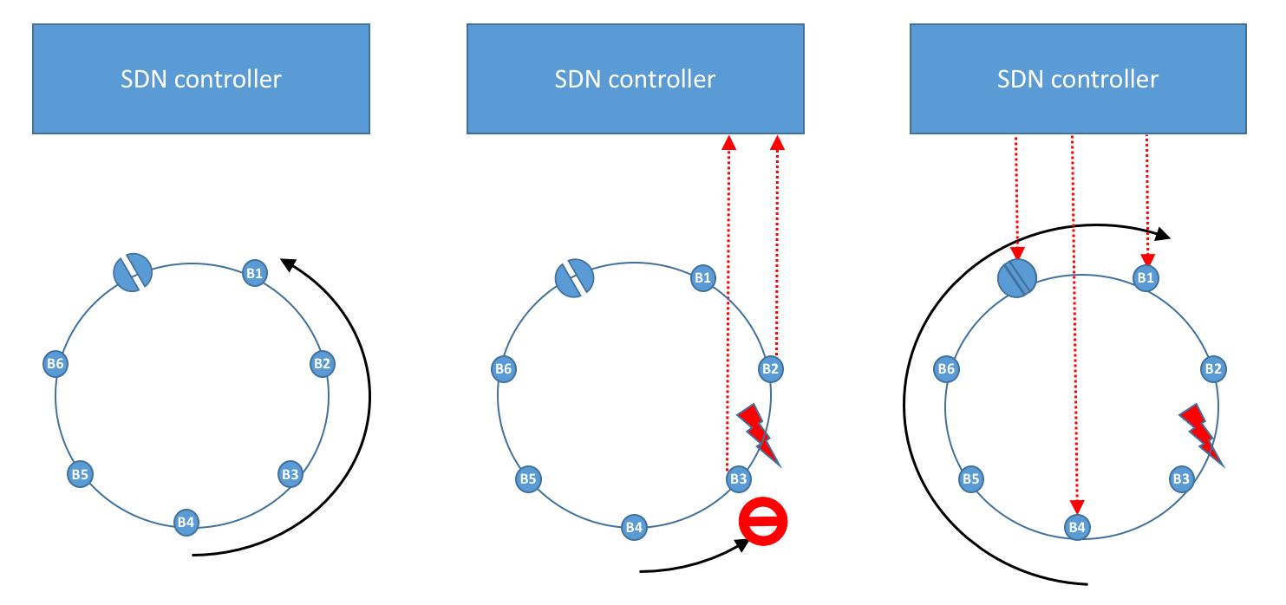

Figure 16: Centralised protection and restoration of unicast traffic

This method does not implement a specific protection, but directly restores the network, taking into account the failure. However, it may be slow as there is at least a round trip time between the nodes and the SDN controller. Moreover, the SDN controller may have to recompute the SIT tables, which may also delay restoration.

The nodes adjacent to the failure will also send a notification to the SDN controller at the end of the failure. The SDN controller could then either download new SIT tables or indicate to the nodes that they should revert to the previous SIT tables (if the latter are not erased during the Failure Recovery phase).

In this centralized architecture, the control channel is not used at all. The SDN controller is responsible for determining that the flow between B4 and B1 is affected by the failure, for taking the decision to reroute the traffic sent to B1and for reconfiguring the switch node. New SIT tables are downloaded by the SDN controller and the nodes only have to act according to these new tables.

### Distributed Protection and Restoration

In case of failure, the two end points adjacent to the failure generate notification failure messages and send them towards the operational directions. The notification failure message carries node ID, interface ID, and other information such as time of the failure; this is carried in a field of the control packet.

Each node relies on a local database to identify which flows are affected by the failure, and thus should potentially be routed in the other direction. This necessitates another table within each node explicitly listing the path taken by each PDU flow known to the node. With the proposed label-based architecture, some flow scan be protected while others are not.



Figure 17: Information relative to the flows concerning D4

Figure 17 shows a Protection Information Table (PIT) that would have to be part of the nodes’ local information database. As the SIT, the PIT is generated when the switch is configured; it is updated by the SDN controller if there is any change in the services it offers as source or destination. When receiving a failure notification, each node uses the PIT to identify which flows are affected by the failure, and can thus take an appropriate decision for each flow identified in its SIT table. This decision (e.g. re-route the flow in the other direction, or stop sending packets corresponding to a flow) shall apply as long as the failure lasts.

Figure 18 shows what happens when a failure occurs between nodes B2 and B3, for a flow sent by B4 to B1.

* On the left hand side of Figure 18, the flow between B4 and B1 runs anti-clockwise before the failure.
* In the middle of Figure 18, the failure has just been detected by the adjacent nodes B2 and B3, which send OAM failure messages in both directions using the control channel. They also alert the SDN controller.
* On the right hand side of Figure 18, the switch node, learning of the failure, decides to allow traffic to pass between B6 and B1, and alerts the SDN controller of its new behavior. Lastly, B4 has determined that the flow sent to B1 should be re-routed in the other direction, and thus restores the flow.

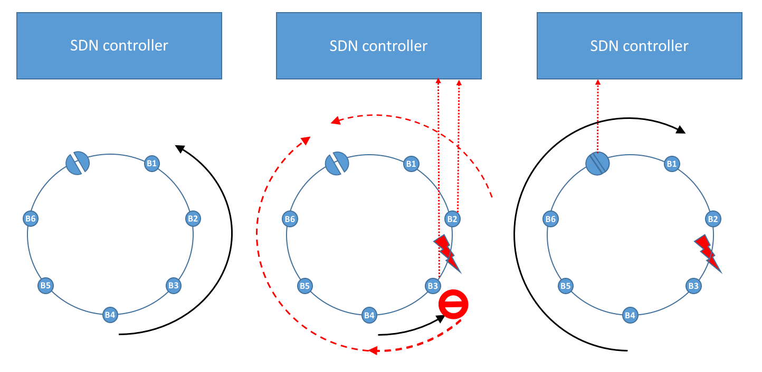

Figure 18: Distributed protection and restoration of unicast traffic

As previously, this method does not implement a specific protection, but directly restores the network, taking into account the failure. It can be very quick, as it is not necessary to involve the SDN controller. However, this complexifies the behavior of each node, and necessitates another set of tables within each node explicitly listing the path taken by each PDU flow known to the node.

The nodes adjacent to the failure also trigger the reaction when the failure stops. A restoration procedure begins as soon as the two nodes at both ends of the failure start receiving control PDUs again. They can thus send out a global notification message in the control PDUs, and ultimately, the network operates as initially.

This architecture takes advantage of the control channel, and the SDN controller does not play any role. Note that with this procedure, node B4 is responsible for determining that the flow between B4 and B1 is affected by the failure, and for taking the decision to reroute the traffic sent to B1. Node B1 should be able to receive a flow in both directions.

### Fast ReRoute: Distributed Protection and Centralized Restoration

In a Fast ReRoute (FRR) procedure, protection is distinct from restoration. Protection typically is a very fast reaction to a failure, which may not use an optimal path, wheras restoration is slower, but attempts to optimize the new path taken by flows.

#### 1:1 Fast Reroute

In 1:1 FRR, each protected flow is dealt with individually. The application of 1:1 Fast Reroute principles to an N-GREEN ring network is illustrated in Figure 19.

* On the left hand side of Figure 19, the flow between B4 and B1 runs anti-clockwise before the failure.
* In the second figure, the failure has just been detected by the adjacent nodes B2 and B3, which send OAM failure messages in both directions using the control channel in order to alert the bridge node. They also alert the SDN controller using OpenFlow.
* In the third figure, the switch reacts to the failure message by allowing traffic to pass from B6 to B1. It sends a message to the SDN controller to make it aware of this new configuration. Also, node B3 sends the traffic from the flow clockwise (i.e. backwards) so that this traffic arrives to B1 from the other direction.
* On the right hand side of Figure 19, the network controller uploads new tables in all nodes, having determined that the flow sent to B1 should be re-routed clockwise. This restores the flow.

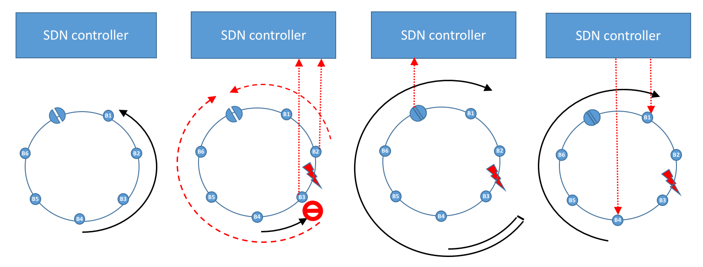

Figure 19: 1:1 Fast Reroute. Distributed protection and centralized restoration

Note that with this procedure, node B4 is not active during the protection period; node B3 does not need to implement a rule specific to a specific flow, only to send backwards any PDU that is marked as protected[2]. Node B1 should be able to receive a flow in both directions, as in the previous case.

#### 1:n Fast Reroute: Distributed Protection and Centralized Restoration

In 1:n FRR, protection is handled globally by the end points on both sides of the failure. The application of 1:n Fast Reroute principles to an N-GREEN ring network is illustrated in Figure 20.

* On the left hand side of Figure 20, the flow between B4 and B1 runs anti-clockwise before the failure.
* In the second figure, the failure has just been detected by the adjacent nodes B2 and B3, which send OAM failure messages in both directions using the control channel in order to alert the bridge node. They also alert the SDN controller using OpenFlow. (identical to 1:1 FRR).
* In the third figure, the switch reacts to the failure message by allowing traffic to pass from B6 to B1. It sends a message to the SDN controller to make it aware of this new configuration. Also, node B3 pushes a new label on top of the original label. This new label corresponds to a path (tunnel) pre-established between B3 and B2 clockwise. When the PDU arrives at B2, the top label (tunnel label) is popped. The next label is the original one, and the packet is forwarded to B1.
* On the right hand side of Figure 20, the network controller uploads new tables in all nodes, having determined that the flow sent to B1 should be re-routed clockwise. This restores the flow. (identical to 1:1 FRR).

Note that with this procedure, neither B1 nor B4 are active during the protection period; node B3 still needs to check whether a PDU is protected before sending it backwards in the pre-established tunnel.

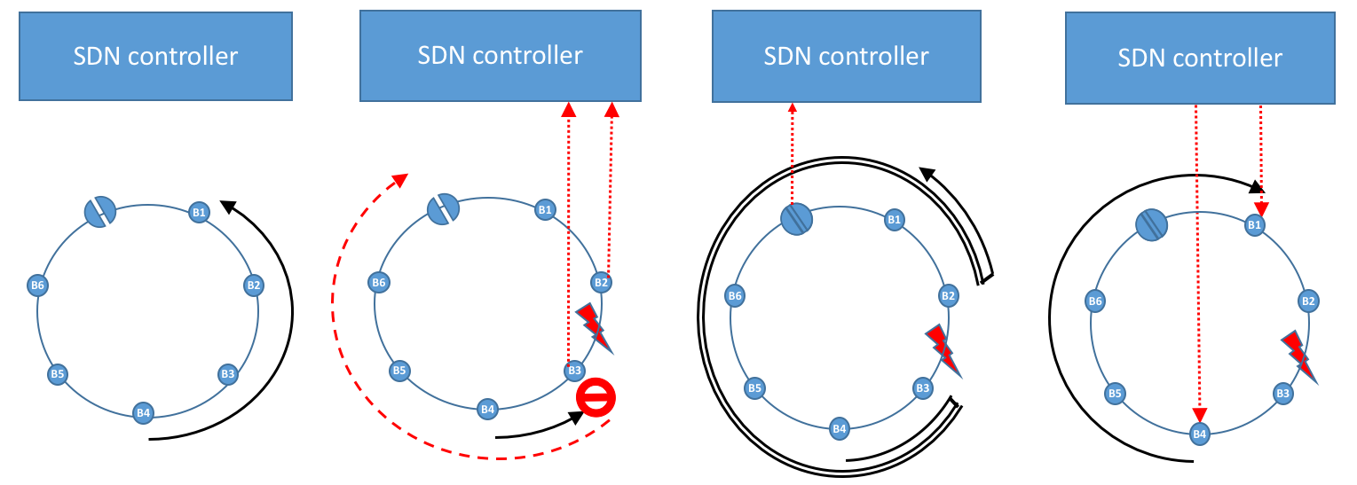

Figure 20: 1:n Fast Reroute. Distributed protection and centralized restoration

### Qualitative comparision between protection/restoration methods

Table 1: Qualitative comparison of protection/restoration methods in an N-GREEN ring network

|  |  |  |  |  |
| --- | --- | --- | --- | --- |
|  | centralized | distributed | 1:1 FRR | 1:n FRR |
| Information centralized in the SDN controller | QoS (Ethernet ou MPLS) (origin:Data Plane)  client VLAN or MAC DSLAM/OLT adress or MPLS label (origin: Data Plane)  Type unicast/multicast (origin: control plane or service plane)  Protected Y/N (origin: service plane)  SDU and PDU labels for all flows (W/P) (origin: SDN controller) | | | |
| Tables in N-GREEN nodes | Client to SDU  SIT-SDU working  SIT-PDU working | Client to SDU  SIT-SDU W/P  SIT-PDU W/P  Network topology  Path per PDU label | Client to SDU  SIT-SDU W/P  SIT-PDU W/P | Client to SDU  SIT-SDU working  SIT-PDU working |
| Actions of N-GREEN switch | SOA activation triggered by the controller | SOA activation triggered by OAM AIS received on control channel | | |
| Actions of nodes at failure edge | Alert controller | Alert controller  Send OAM AIS on control channel | Alert controller  Send OAM AIS on control channel  Send protected traffic backwards | Alert controller  Send OAM AIS on control channel  Push PDU label, and  send protected traffic backwards in tunnel |

# Approaches for Performance and techno-economic evaluation

## Specification of the KPIs, and selected benchmark

### KPIs

The following performance parameters shall be considered for different CoS

* SDU latency
* SDU delay variation
* SDU loss ratio

Note that SDU latency is a one-way delay and that it is the sum of

* encapsulation delay: time spent between the arrival of the first bit of the client frame in the N-GREEN source node and the instant when the PDU is ready to be inserted;
* insertion delay: time spent between the instant the PDU is ready to be inserted and the instant the last bit of the data PDU is inserted on the optical channel;
* propagation delay: time spent between the instant the PDU is inserted on the optical channel and the instant the first bit of the data PDU is received by the electronic layer of the destination N-GREEN node;
* decapsulation delay: time spent between the instant the first bit of the data PDU is received by the electronic layer of the destination N-GREEN node, and the instant when the last bit of the client frame is delivered to the client node.

Relying on proposed QoS classes defined in [3] and specifying a new class for CPRI traffic, the following CoS can be considered :

* D (deterministic): CPRI traffic
* H (high) : real time traffic (e.g. ToIP, videoconference)
* M (medium) : guaranteed data (IPTV, entreprise data, interconnection between data centers)
* L (low): Internet data

D would not be supported for all Network Scenarios identified in Section II.2.3, but only for the xHAUL network scenarios. The other classes could be supported for all scenarios. Table 2 reports objectives set by the MEF for unicast Ethernet traffic. N-GREEN networks should at least support these objectives.

Table 2: MEF target CoS values for unicast traffic in metro networks ([3])

|  |  |  |  |
| --- | --- | --- | --- |
| KPI parameter | H | M | L |
| SDU latency | 10ms | 20ms | 37ms |
| SDU delay variation | 3ms | 8ms | NS |
| SDU loss ratio | 10-4 | 10-4 | 10-3 |
|  |  |  |  |
| ………….. |  |  |  |

#### Insertion delay

Insertion delay refers to the time for which client traffic must wait before it is aggregated in the optical packet. Two processes may have impact on the insertion delay. The first one is the waiting time in the electronic buffers (known as buffering time). Although we assume that electronic buffers have infinite sizes, buffering time may vary depending on whether classes of service are considered or not and also thanks to statistical multiplexing. The second one is the waiting time for container full (or partial) filling (container construction). For instance, best effort traffic can be taken off from the optical packet if high priority traffic arrives before sending the container. In addition, the waiting time for packet insertion can be as small as 1µs if the ring is busy when the container is constructed. This is specific to N-GREEN node whereas this time is at least equal to 10µs for other optical slot switching technologies like POADM.

Regarding CoS1 traffic, the global end-to-end delay, from the RRH to the edge cloud (BBU) in 5G including the processing, should be less than 500µs. This is a common hypothesis, based on the constraints for 5G traffic [2][10].

### Benchmarks

The first benchmark is the current electronic packet network based on Ethernet carried over an optical transport network (ROADM). This can be referred as “packet optical” in the literature.

Other benchmarks can be considered: optical circuits based on ROADM, optical packets with either ECOFRAME or TWIN architectures

## Performance evaluation approaches

In this section we show the methodology adopted to assess the performance of the network. In order to avoid distorting the results, the extra-resources allocated for protection are not considered in the performance study.

### Mathematical models and simulation platforms

The access to the medium is mathematically modeled using the queuing theory.

The project partners will use the following tools for performance evaluation:

* TB: dimensioning tools (heuristics for large networks)
* TSP: an extension of NS3 simulator.
* TPT:
* DAVID:
* Nokia Bell-Labs: NS3 for complementary simulations. Gwatt platform for the energy consumption analysis and the benchmarking with other solutions.

### Simulation scenarios

The scenario contains the physical and the logical topology, the traffic matrix, the QoS of flows.

The following texts seems to be very detailed. To be simplified?

#### Insertion delay

Some already obtained results from node-level simulations show that this delay is mostly less than 20 µs whatever the load. Furthermore, the insertion delay could be further minimized taking benefit from the N-GREEN over-dimensioned nodes in low load cases. To this end, we will evaluate two different scenarios. In the first scenario, the non-used wavelengths assigned to given time slot might be used by another node provided that the corresponding fixed lasers are free (resource sharing in spectral domain). This last constraint may reduce the efficiency in resource utilization. In addition, this scenario works only with the Broadcat-and-Select mode since all packets groomed in the same time slot by different nodes should be erased together. This means that this WDM slot sharing scenario can be done only during one time slot cycle. During the its next cycle, the container should be erased by the last node that has shared it and not necessarily by the first node that created it.

The second scenario shares resources instead in the time domain. In other words, it considers a very small time granularity (e.g., 100 ns) in order to better use the partially used resources and therefore improve latency. This scenario is not however limited to the Broadcast-and-Select mode since each node uses all the wavelengths for its packets (colored packets) during a small time slot before they are later erased by their destination node. However, additional time guard bands should be considered in the last scenario.

#### Periodic latency guarantee

In the context of guaranteed latencies for C-RAN applications described in Section II.2.3.3, **periodic** communications would fulfil the requirements in terms of latency, availability and security of transmissions that the N-GREEN network architectures have to ensure.

New scheduling and routing paradigms have to be implemented at the control plane level to solve this periodic and delay constrained data transfer. This would implement Deterministic Networking (DN) over a WDM network. DN avoids statistical multiplexing by replacing traditional queue management procedures by time based forwarding. Solutions for DN are under standardization in IEEE 802.1 TSN group, as well at IETF DetNet working group.

To make DN work over an optical WDM network composed of several nodes, it is required to manage the time at which the slots of deterministic paths are crossing each node, and all the nodes through the network have to be sufficiently synchronized to avoid contention. This management has to be considered and compared in the two information distribution modes, i.e., the unicast/multicast mode and the broadcast-and-select mode. The impact of each mode on the end-end delay constraints has also to be quantified considering the node architectures. Moreover, the continuity of deterministic routing has to be ensured inside the restoration processes in case of one link failure (see Section III.6).

#### Mechanisms of slot transmission in both rings

The performance of N-GREEN network will be investigated within different mechanisms of slot transmission, in particular in double unidirectional ring architecture, as it is common for metro aggregation networks. The two rings are used for transmission and protection targets. A “switch node” guarantees the rings synchronisation, while other nodes are “bridges”. In case of path failure, the optical bypass of the switch node is activated.

For unicast transmission between two bridge nodes, packets are sent via the ring (direction) that avoids passing through the switch node in order to avoid any O-E-O conversion: lower delay and lower energy consumption.

For unicast transmission between the switch node and a bridge node, and for multicast transmission emitted by the switch node or transmitted to the switch node for forwarding, we consider the following scenarii:

* “Double bidirectional transmission” scenario consists of sending the same packets on the two rings simultaneously. The resources’ use is not optimum, however, the control is simple and the protection is guaranteed: in case of path failure through one ring, packets will arrive to their destinations through the second ring.
* “Shortest path unidirectional transmission” scenario consists of sending packets to their destinations through the unidirectional ring corresponding to the shortest path. It may be determined by the transmission distance (less intermediate nodes) or by the load. In case of path failure through one ring, packets will be reemitted via the second ring. This is illustrated in Figure 21. The use of the resources is optimum but at the expense of the control complexity (determination of the shortest path, informing the SDN orchestrator in case of failure, reemission via the second ring). Moreover, in case of path failure, the latencies may be higher than those of the 1st scenario, since the packets must be re-emitted via the second direction (ring).
* “Distributed unidirectional transmission” scenario consists of sending a certain percentage x% of the traffic via a first ring and the rest y% via the second ring. The resources’ use is not optimum as in the 2nd scenario but could better than the 1st scenario. In case of path failure via one ring, just one part of the traffic (x or y%) will be re-emitted through the second ring. Each scenario of slots transmission and each emission method results in a different energy consumption state that we will estimate in order to determine which scenario/emission method leads to the best compromise between the performance (in terms of frame latency and frame loss ratio) and the energy consumption.

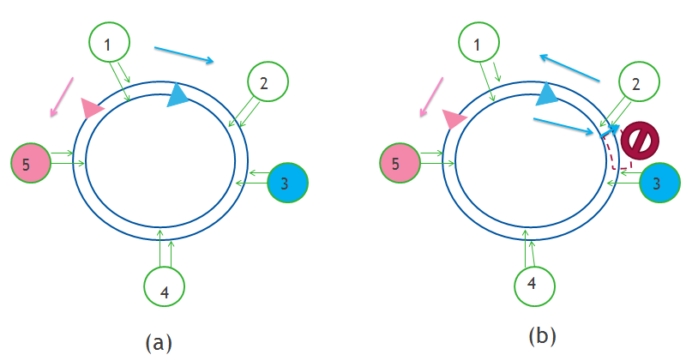

Figure 21: Shortest path unidirectional transmission scenario (a) normal operation, (b) failure case

## N-GREEN network dimensioning

This section describes the dimensioning methodology adopted to dimension N-GREEN networks, to enable techno-economic comparison with reference technologies such as Ethernet, optical circuit switching, POADM and TWIN.

In general terms, dimensioning a network refers to finding an optimum resource allocation (among those provided by a given technology) allowing to carry a set of source/destination demands (traffic matrix).

The difficulty of the N-GREEN dimensioning problem depends widely on the use case. In the single-ring case, the problem is quite similar to the Routing and Wavelength Assignment problem in WDM circuit-switched ring. The main difference with the circuit-switched case is the statistical nature of the input traffic that imposes to bound the capacity of a multi-wavelength channel to γ×B where B is the nominal channel capacity. It has been shown that γ = 0.8 allows maintaining the input latency below 100 time slots [4]. Note that the N-GREEN approach (where each node has as many emitters as the number of wavelength bands it uses to send traffic) doesn’t suffer from the stability issue encountered in POADM networks, when a node may send traffic on several wavelength channels but can emit only one packet per time slot [5].

Moreover, we note that the resource allocation will depend on whether traffic demands may be split over several wave-bands or not. This is illustrated by the example shown in Figure 22 and Figure 23. In this example, a concentration/distribution scenario is assumed. The capacity of a wave-band is 100 Gbit/s. For the sake of simplicity, γ factor is not taken into account and uni-directional routing is used. This example also shows that the necessary conditions: (i) the Tx/Rx capacity in a node must be able to carry all the traffic sent/received by this node, (ii) the number of wave-bands must be high enough to support the traffic of the most occupied arc of the ring, are not sufficient when traffic demands cannot be splitted.



Figure 22: dimensioning example (concentration/distribution scenario with 28 Gbit/s per ring node),   
w/o traffic splitting: three 100 Gbit/s wave-bands are necessary.



Figure 23: dimensioning example (concentration/distribution scenario with 28 Gbit/s per ring node),   
with traffic splitting at node 1: only two 100 Gbit/s wave-bands are necessary

Finally, it is worth to note that, in practical network scenarios (assuming today’s traffic and a 10×10 Gbit/s capacity per band), deploying a single wave-band per bus (or ring) and a single Tx/Rx array per node will be sufficient. This simple situation will serve as a starting point for techno-economical analysis based on the evolution if the traffic and on the deployed equipment during a given period.

The reference topology for the dimensioning studies is derived from the German network (see Figure 24).



Figure 24: reference 17-nodes meshed network topology (distances in km).

Up to now, this meshed topology has been addressed by mapping on it one or several N-GREEN rings. Examples with one and three rings are shown on Figure 25 and Figure 26, respectively. Alternative designs based on buses (as the one of the Figure 2) will be considered later during the project. For the moment, we just note that a priori three cases can be distinguished:

* One single ring including all the nodes
* Several rings covering all the nodes with interconnection nodes that enable to connect a pair of nodes belonging to different rings[3]
* Several rings covering all the nodes with the assumption that there is at least one ring shared by each pair of nodes [Lida ONDM 2013].



Figure 25: network of Figure 24 covered by a single ring.



Figure 26: network of Figure 24 covered by three interconnected rings.

## Techno-economic assessments

In this section, we describe the techno-economic method adopted to quantify CAPEX and OPEX in N-GREEN networks. The target is to compare the network cost for various technologies over a N year period (N depends on the traffic growth law).

### General approach

The key performance indicators of equipment constructors, above the technical requirements, are mainly the cost and the energy consumption. Both criteria are extremely important to be competitive on the market place.

Energy efficiency has been identified by the World Energy Council as a key direction to follow to have a major impact on the industry and on CO2 emission reductions.

An internal analysis, facilitated by the internal development of the GWATT tool ([www.gwatt.net](http://www.gwatt.net)) demonstrates also that there is a need to optimise the energy efficiency of ICT to support the traffic growth and limit the part of the ICT power consumption to less than 6% of the total power consumption as estimated at a worldwide scale in 2013.

The N-GREEN project, targets then a gain on both economical and energetical aspects. The systems investigated in this project are eco-designed in order to have potential products that minimise their energy consumption. In particular, N-GREEN proposes a new network model where only the dropped traffic is processed while the rest of the traffic goes through the node without electronic processing.

In order to identify the true benefits of these new system and network solutions, we will look forward two aspects of the cost : the CAPEX and the OPEX.

The objective is to point out that the new solution proposed is not a relative optimum, but converges to an absolute optimum by taking into account different parameters: energy efficiency, cost efficiency, protocol efficiency, network efficiency and spectral efficiency. Therefore the optimum must take into account different levels of optimisations.

Concerning the CAPEX, we want to compare the major relevant aspects of this new solution, such as the CAPEX cost both at network installation and at the end of its lifetime.

But the cost is conditioned also by OPEX, that includes the energy consumption, the upgrade costs, and also the maintenance costs. To minimize these OPEX costs, we want to have then highly programmable systems that can be upgraded without sending an operator on a physical site. The network design might impact then both CAPEX and OPEX dramatically. It is then fundamental when we do techno-economic studies to integrate CAPEX and OPEX analysis and have a reference model to quantify how the proposed concepts are better optimised.

Moreover, to be more accurate, we can also take into account the MTBF (Mean Time Before Failure) to evaluate another important part of the costs of the network: the reliability.

We will be then able to show a trustable comparison between the N-GREEN solution and the reference model.

In summary we will adopt two methods to do the benchmarking studies:

* A first one focused on a **comparison study** with a network reference model.
* A second one method exploiting the **gwatt tool** to investigate the broader impact of the energy consumption savings of ICT, if this technology is widely deployed (see IV.5.)

### The comparison method

To make a good comparison, the N-GREEN solution will be compared with another reference functional model in order to show the cost of each solution during its life time.

Even if other references may be examined like POADM technology (Packet Optical Add/Drop Multiplexer technology), ROADM technology (Reconfigurable Optical Add/Drop Multiplexer technology) and finally the WDM (Wavelength Division Multiplexing) technologies, only one will be our reference : the Ethernet technology, as it now widely developed in the network segments targeted by N-GREEN.

To explicitly determine the differences between each model concerning both cost and energy, we start by decomposing each technology in sub-blocks and key components.

For example the Ethernet technology will be split into four main sub-blocs : the TRX, the line cards, the switch and the scheduler.

The WDM Slotted Add/Drop Multiplexer technology as proposed in N-GREEN will include the optical bypass, the controller, the TRX the line cards and the client cards.

To compare the different node models, we study the evolution of the models during a relative period of N years assume (for instance) that the yearly traffic growth rate can be supported by a node port capacity of 100Gbit/s (i.e. 10 Gbit/s per wavelength) during the first half of the period and by a node port capacity of 1 Tbit/s (i.e. 100 Gbit/s per wavelength) during the second half period.

Taking into account the traffic evolution law, we can then adjust the time line to the predicted product lifetime.

To compare the prices between the models, we divided each technology in two parts :

* The TRX one, which includes the TRX and the interfaces.
* The switching one which includes the rest of the system.

The global figure, integrates these two parts. Because these models need to be constructed, we also added all the costs needed each time it is necessary to upgrade model and add more components.

Some technology requires to be more upgraded than others and need more engineering. To do so, we evaluated how much it might cost for each operation.

For each device, we needed many information such as the price range and the consumption.

Obviously for each model, we had to care about the consumption because electricity costs money, so we calculated and included the electricity cost in the global cost..

Preliminar results

**Study case: 10 nodes ring network.**

* Capacity of the node : 100G and then 1T after half period
* 9 core nodes, 1 edge node
* Perfect reliability
* Study made on a relative capacity growth



Figure 27: Evolution of the cost of a 10- nodes ring network   
for Ethernet and N-GREEN (WSADM) technologies.

Figure 27 shows that the cost gain compared to an Ethernet technology is effective in this example.

However, these results are dependent on several factors, in particular the number of transit nodes. More complete network analysis will be made in the WP3.

## Energy consumption evaluation

To complete the studies, we will compare in a second step the impact of this WSADM technology for different copertures, and in comparison with the currently deployed technology.

To do this, we will exploit then the gwatt tool ([www.gwatt.net](http://www.gwatt.net)).

We will then create an Excel data sheet, readable by the gwatt tool, to estimate the energy consumption gain for a wide deployment. The main values we need to provide are : the energy efficiency of the solution and the traffic perspectives. The date target will be 2020.

The tool is describe in Figure 28. The tool gives the possibility to select the technologies per network segment. For the N-GREEN project we will address the access aggregation.

When feeded with the correct values of the energy efficiency and the traffic evolution, it will be possible to estimate the power consumption of the proposed technology, and do a comparison with a given reference, e.g. GPON access networks interconnected by MPLS. The comparison can be done for different introduction levels: at a country level, at a group of countries level or at the world level. The projected gain during a time period, as shown in Figure 29, can be quantified in terms of Euros, Tons of CO2, or other criteria.

These studies will complete the CAPEX and OPEX benchmarking studies to better estimate the benefits brought by N-GREEN solution.



Figure 28: Network synoptic and selection of technologies per network segment.



Figure 29: Energy gain obtained per year, with different units  
 (euros, saved Megatons of CO2, …).

# Physical Aspects

## NGREEN physical limits

We focus here only on the physical limits impacting the signal quality at the end of the network.

For metro/aggregation network scenarios (respectively sections II.2.3.1 and II.2.3.2), in addition to the chromatic dispersion and thermal effects, we identify five main physical limits, of first order, for short reach networks that need to be analysed.

* **Extinction Ratio** (ER) degration due to the **Cross Gain Modulation** in Semiconductor Optical Amplifiers (SOA). This ER degration evolution will be calculated through a simulation tool.
* **Optical Signal to Noise Ratio** (OSNR) degradation due to the optical noise amplification and to an **Amplified Spontaneous Emission** (**ASE**) generation when crossing SOAs. This characteristic will be estimated using a simulation tool.
* **Four Wave Mixing** (FWM) cumulation, created in the SOA due to an optical power injected too high. This FWM will be characterized using an experimental test bed, and a model for the power dynamic range will be also identified.
* **Coherent Crosstalk** (C-XT) cumulation. This physical effect is created when the On/Off ratio of the gating function is not high enough. Experiments have been realized to identify the required **On/Off ratio of SOAs** to avoid any significant extra sensitivity penalty measured at the reception side.
* **Power Dynamics** (PD) in the time domain and in the spectral domain. In the time domain the power discrepancies can be created by components sensitive to the **polarization** state of the light, by **non ideal uniformity** between different paths or simply by a **non uniform distribution of the insertion losses** in parallel paths. In the spectral domain, the power discrepancy is created by a **non ideal flat transfer function** of the optical bandwidth of mux, demux and SOAs. The objective is to do simulation and experimental tests to identify proper mechanisms to control the power and the OSNR at the network level.

All these studies will be made at the network level in the perspective to demonstrate that we can obtain a sufficiently good signal quality to avoid any FEC in the receiving part of the nodes. **The reference is 10-15 in terms of BER.** Figure 30summarises the physical effects that will be studied, at the network level.

## Upgradability and scalability issues

The upgradability and the scalability issues will be studied in the WP4 of the N-GREEN project.

For the upgradability, we will analyse different traffic scenario, and illustrate how the network can be upgradated.

For the scalability we will address two aspects:

* Scalability at the capacity level per node. The focus here will be on the number of TRX implemented and on the support of higher TRX capacity (10x100G instead of 10x10G).
* Scalability in terms of number of nodes interconnected. The focus here will be on the mechanisms that need to be implemented to be able to add one or several nodes in the network.

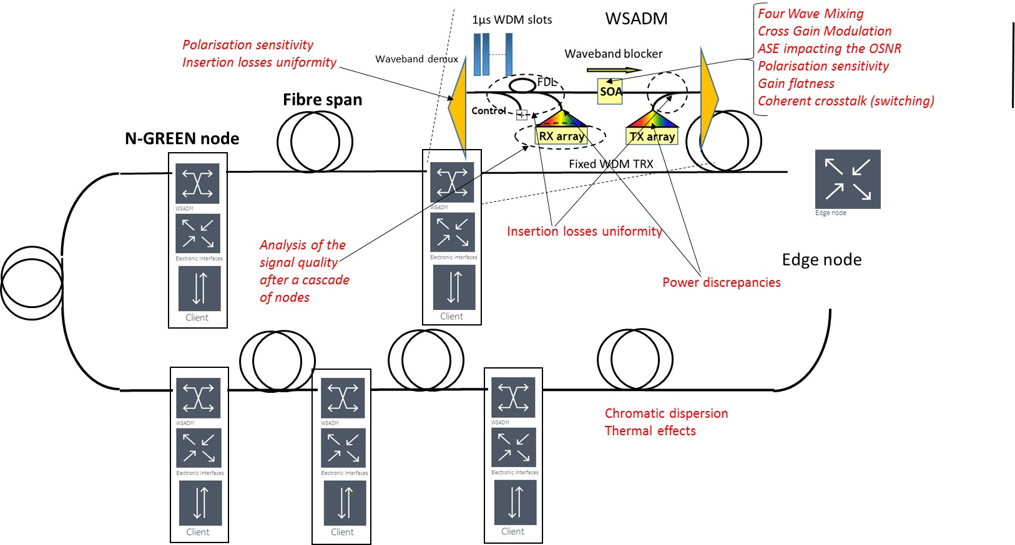

Figure 30: N-GREEN node studied in the frame of a ring network topology. We assume that the singals are terminated at the edge node

The different impacts of each physical aspect of the selected technologies on

* the node design
* the data protocol
* the control channel
* the SOA and TRX specifications

are highlighted in Table 3.

Table 3: Impacts of the different physical effects on the network on the node, on the data channels and on the control channel.

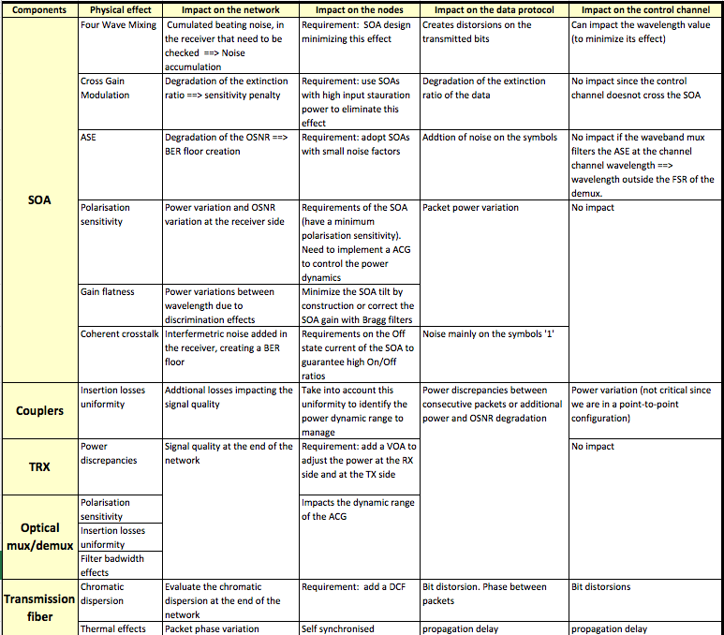

# Conclusion

This deliverable provides a detailed presentation of a new optical networking technology proposed in the framework of the N-GREEN project, relying on a WDM slotted optical packet structure, and addressing various network segments from metro/access to backbone.

We first recalled the context these networks are facing, in particular, the steady traffic growth, the foreseen impact of 5G deployment on the wired network, the evolution of data centre localization, the need for a better energy efficiency and the emphasis on SDN-based network control. As it natively provides optical transparency and statistical multiplexing, optical packet switching has been for a long time identified as an attractive solution to satisfy these different requirements. But, technical maturity and equipment cost represent major issues for this kind of technology, particularly in metro segments where Ethernet has become a widespread solution. However, by exploiting the parallelism enabled by several optical devices (e.g. optical gates or switches) or by the development of optoelectronic integration on Si or InP substrate, WSADM technology is expected to be viable from a techno-economical view point in the near future.

We then gave an overview of the proposed technology. The analysis addressed both transfer and control planes, and described different protection mechanisms and options to control them. Several use cases were described, that led to distinguish between two main variants. A common feature among these variants is the use of WDM slotted packet formats where PDUs are carried over a 1 µs slot spread over a 10-wavelengths band and the control channel is carried over a separate wavelength channel.

The first network architecture variant is in-line with earlier analysis carried in the project and provides unicast or multi-cast connections with possibly different classes of service. It may be applied in various network segments from metro/access to backbone, either with ring or mesh topologies. In the physical ring topologies, the N-GREEN solution takes the form of a closed bus where the node closing the bus, named “switch node” includes an electrical bridge (only used for protection) while the other ones, “bridge nodes” are crossed transparently. The second variant has been identified more recently and addresses a specific but important use case, namely 5G X-hauling, where latency requirements may be very stringent. It only provides broadcast connections and operates, to some extent, like a PON.

For both variants we put the emphasis of the use of labels, at both PDU and SDU levels in order to control optical packets and client flows, respectively. The label structure is similar to the one used in MPLS, and the proposed switching method is quite similar to the one used for Segment Routing. Assuming these different options, we were able to detail the structure of WDM data packets and control packets for both variants of N-GREEN solution and to describe the structure and the operation of Forwarding Information Bases, also for the two variants. The different tables constituting these bases can be directly downloaded by a SDN controller.

We then envisioned different approaches for protection operation. Two extreme scenarios were identified, namely a fully centralized where protection and restauration are operated by the SDN controller and a fully distributed one, where all decisions are taken locally on the basis of control channel information. The last option enables very short protection and restauration times, roughly limited by the propagation time. However, it relies on extensive knowledge by the nodes of the routes taken by the flows that are crossing them. Using a FRR-like method, also described, could be a suitable trade-off as it provides fast protection, without requiring the dissemination of per flow information, while restauration of the optimal route is set-up by the SDN controller.

Based on the above use-case identification and technology description, we could then present the methodology for the assessment of the proposed solutions.

A first framework for assessment deals with the technical performances that could be achieved in realistic operational conditions. To this end, performance evaluation using either analytical models or simulation platforms will be carried out, with an emphasis on a set of KPIs of SDU transport (delay, delay variation and loss ratio) and four different CoS. Complementary studies will address specific mechanisms that could be necessary to improve a KPI in a given context, e.g. to provide a periodic guarantee of the latency or to arbitrate between various SDU insertion strategies in a dual fibre ring. Such performance evaluation has to be carried in a properly dimensioned network, in order to get realistic network performances. Ring networks may be dimensioned with minor changes of tools previously developed for single wavelength packets. The case of mesh networks shall require more extended investigations that could rely on previous work by some partners, e.g. on ring covering algorithms.

The techno-economic analysis of the N-GREEN technology represents another key assessment framework. Both CAPEX and OPEX need to be evaluated. Among OPEX, the issue of the energy consumption represents by itself a major concern, for environmental and societal reasons. Tools, like the gwatt software, will be used to have an insight on the impact of a wide scale deployment of the N-GREEN technology in terms of e.g., tons of CO2, in comparison to more conventional technologies. For cost comparison, the approach that will be followed involves considering a given network during a period characteristic of a typical equipment life-time (~ 10 years) and taking into account traffic growth assumptions and capacity up-date during that period. This method enables capturing the pros and cons of the “overdimensioning” feature resulting from the use of 10-wavelength groups. It also enables an easy integration of both CAPEX and OPEX. The N-GREEN technology will be compared with other OPS technologies, to get a better understanding on their relative cost structures, but Ethernet technology will constitute the real benchmark. We presented preliminary results that seem quite encouraging and tend to confirm the strategic technical choice by N-GREEN of exploiting the parallelism provided by WDM and using relatively mature devices.

Finally, in spite of this relative technological maturity, the N-GREEN technology still deserves a lot of technical studies to assess its feasibility and to evaluate its scabilty. The latter point refers to both node capacity (for instance the condition to upgrage the channel bit rate from 10 to 100G) and the network extension in terms of number of nodes that can be cascaded transparently and/or total fibre length. It is worth noting that these physical limits are not completely independent from the network level requirements. In particular, use-cases requiring extremely low latencies may prohibit using a FEC and thus lead to much more severe physical limitations. Also some of the physical limits are common with single-wavelength OPS technologies while other are specific to the concept of WDM packets (e.g. the power monitoring issues).

The results of these different assessment frameworks (including technological studies carried within WP3 and 4) will serve as a basis for a revised and complemented description of the N-GREEN networking solutions that will be presented in the final phase of the project in deliverable D1.2f.

# References

1. A. D. La Oliva et al., "Xhaul: toward an integrated fronthaul/backhaul architecture in 5G networks," in IEEE Wireless Communications, vol. 22, no. 5, pp. 32-40, October 2015.
2. A. Pizzinat, P. Chanclou, F. Saliou and T. Diallo, "Things You Should Know About Fronthaul," in Journal of Lightwave Technology, vol. 33, no. 5, pp. 1077-1083, March 2015.
3. MEF, “MEF 23.1, implementation agreement, carrier ethernet class of service phase 2,” tech. rep., 2012.
4. USCUMLIC Bogdan, “Optical architecture and traffic engineering in optical metropolitan networks”. Th. doct. : Sciences et technologies de l'information et de la communication, UBS, UEB, Institut Mines-Télécom-Télécom Bretagne-UEB, 2010.
5. USCUMLIC Bogdan, GRAVEY Annie, CERUTTI Isabella, GRAVEY Philippe, MORVAN Michel, “Stable Optimal Design of an Optical Packet Ring with Tunable Transmitters and Fixed Receivers”. ONDM 2013 : the 17th International Conference on Optical Network Design and Modeling, 16-19 april 2013, Brest, France, 2013
6. SADEGHIOON Lida, USCUMLIC Bogdan, GRAVEY Philippe, GRAVEY Annie, “Fully transparent design of a hybrid optical packet/circuit metropolitan area network”. ONDM 2013 : the 17th International Conference on Optical Network Design and Modeling, 14-19 april 2013, Brest, France, 2013, pp. 263-268
7. T. Eido, T.D. Nguyen, T. Atmaca, “Packet Filling Optimization in Multiservice Slotted Optical Packet Switching MAN Networks”, AICT’08, Athens, Greece, June 3-8, 2008
8. T.D. Nguyen, T. Eido, T. Atmaca, “DCUM: Dynamic Creation of Fixed Containers in Multiservice Synchronous OPS Ring Network” QoSIM'2009 (2nd International Workshop on Evaluation of Quality of Service throug Simulation in the Future Internet), Rome, Italy, March 6, 2009
9. T. Atmaca,T. Eido, T.D. Nguyen, D. Chiaroni,G. Buforn, “Aggregation Issues in Time Slotted Packet Ring Network"; Photonic Switching (PS)2009, Pisa , Italy, September 15-19, 2009
10. NGMN Alliance, “5G White Paper”, February 2015. <https://www.ngmn.org/uploads/media/NGMN_5G_White_Paper_V1_0.pdf>

1. Introduced by the ECOFRAME ANR project (2007-2010).
2. It is not necessary in the present case to build a « protection path » for the initial flow, but only to have a simple rule at B3 stating « in case of failure on the link B2-B3, send protected traffic in the other direction. This would be different in a mesh network, as there would be multiple other directions available.
3. For a given traffic matrix, the ring designed may be optimized by following an approach similar to the one presented for POADM by [Pointurier, ONDM 2012]